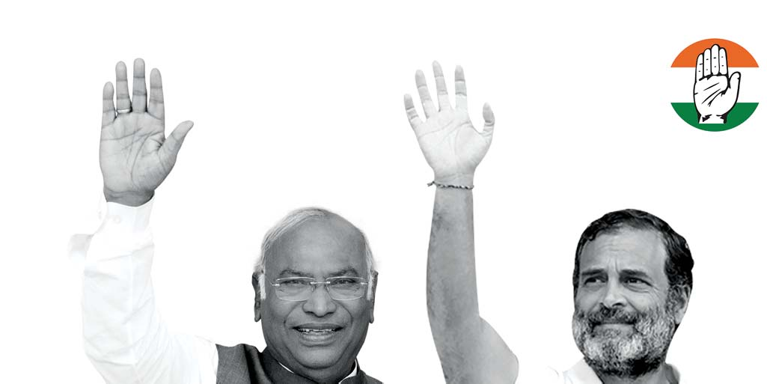
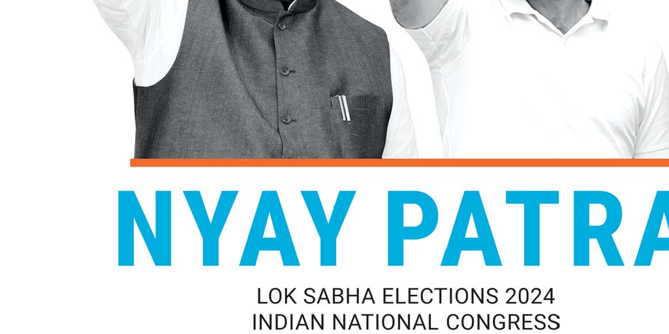
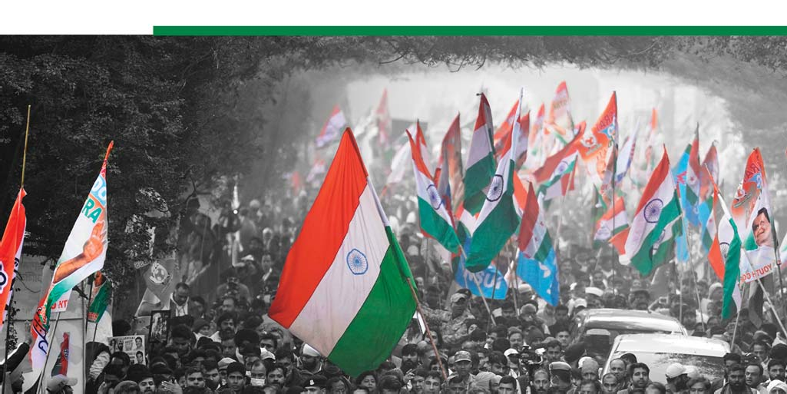
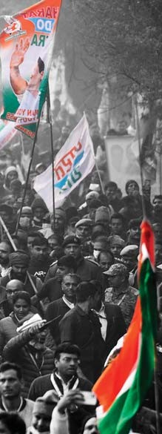
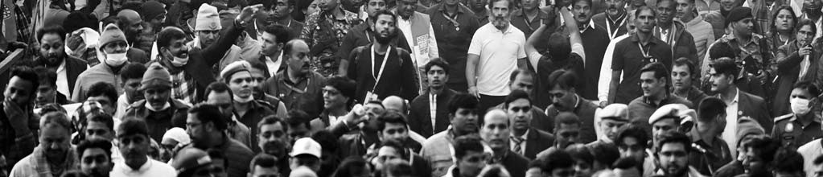

Introduction .......................................................................................... 3
- Equity ................................................................................................ 6
Social Justice........................................................................................................................ 6
Religious and Linguistic Minorities ..................................................................................... 7
Senior Citizens, Persons with Disabilities, and LGBTQIA+................................................. 8
Health ................................................................................................................................... 9
- Youth ............................................................................................... 11
Jobs ...................................................................................................................................... 11
Education .............................................................................................................................. 12
Sports ................................................................................................................................... 14
- Women ............................................................................................ 15
Mahalakshmi........................................................................................................................ 15
Women’s Empowerment...................................................................................................... 15
- Farmers ........................................................................................... 17
Fishing and Fishing Communities ...................................................................................... 19
- Workers ............................................................................................ 20
- Defending the Constitution................................................................ 21
Saving Democracy, Removing Fear, Restoring Freedom .................................................... 21
Reversing the Damage ......................................................................................................... 22
Media .................................................................................................................................... 23
Judiciary ............................................................................................................................... 24
Anti-Corruption .................................................................................................................... 25
Art, Culture and Heritage ..................................................................................................... 26
- Economy ......................................................................................... 27
Our Economic Policy ............................................................................................................ 27
Unemployment – Meeting The Cry For Jobs ...................................................................... 30
Taxation and Tax Reforms ................................................................................................... 31
Industry ................................................................................................................................. 32
Infrastructure ........................................................................................................................ 33
- Federalism ..................................................................................... 35
Centre-State Relations ......................................................................................................... 35
Rural and Urban Development.............................................................................................. 36
North Eastern States ............................................................................................................ 37
- National Security .............................................................................. 38
Defence ................................................................................................................................. 38
Internal Security ................................................................................................................... 39
Foreign Policy ....................................................................................................................... 40
- Environment ...................................................................................... 42
Environment, Climate Change and Disaster Management ................................................ 42
Water Management and Sanitation...................................................................................... 43
An Appeal .............................................................................................. 45

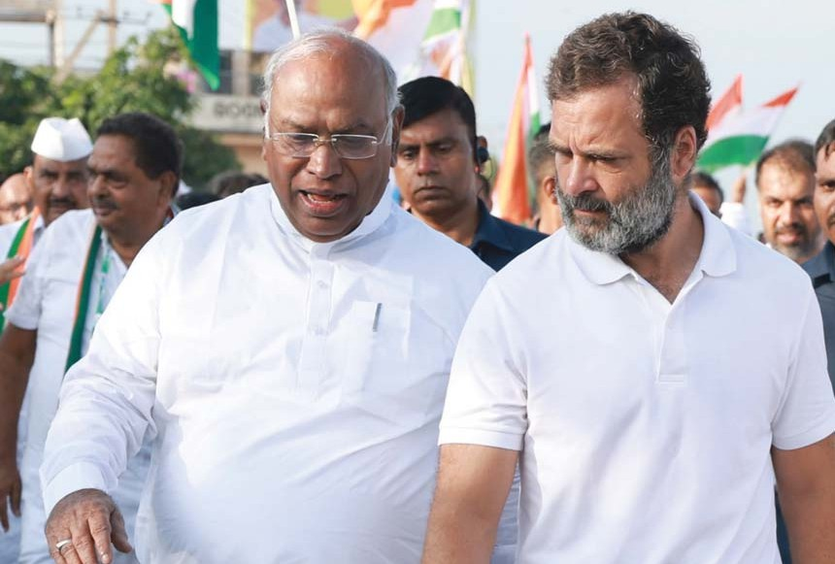

We reiterate that the Constitution of India shall remain our sole guide and companion in our never-ending journey.

Introduction

At every stage of its 138-year journey, the Indian National Congress had identified itself with the problems, develop- ment, aspirations and hopes of all the people of India. During the freedom struggle, its foremost aim was to win freedom. It was guided by the wisdom and sacrifice of great leaders like Mahatma Gandhi. After independence, the Congress’ article of faith was the Constitution of India of which Dr Babasaheb Ambedkar was the prime architect.

Since 1947, the Congress has been India’s beacon of hope. Our policies brought about rapid industrialisation in a predominantly agrarian economy, transformed India from a famine-struck country to one that exports food grains to countries around the world, laid the scientific and technical foundations for India’s rise as a global software powerhouse, and built world class institutions in research and higher education whose graduates are seen as at par with the world’s best. Even as liberalisation and reforms caused economic growth to boom under successive Congress governments, our social welfare policies ensured that every citizen was able to participate in the India story. The social welfare net created by the United Progressive Alliance (UPA) such as the Mahatma Gandhi National Rural Employment Guarantee Act (MGNREGA) and the National Food Security Act ensured that India was able to absorb the shocks of the Global Financial Crisis (2008), the Taper Tantrum (2013), demonetisation (2016) and COVID-19 (2020).

Five years ago, on the eve of the Lok Sabha polls, the Congress had published a 54-page manifesto. Based on the record of the first term of the Modi government, we had forewarned the people of the precarious state of our polity and economy, and of the danger of re-electing the BJP/NDA government. Our assessment of the situation in the country has, alas, proved true. Many of the weaknesses and woes have deepened in the last five years. The promises and assurances that the Congress gave in its 2019 manifesto remain valid and doubly relevant today. Hence, we will start with endorsing our 2019 manifesto and urge you to read the statements here as part of this manifesto.

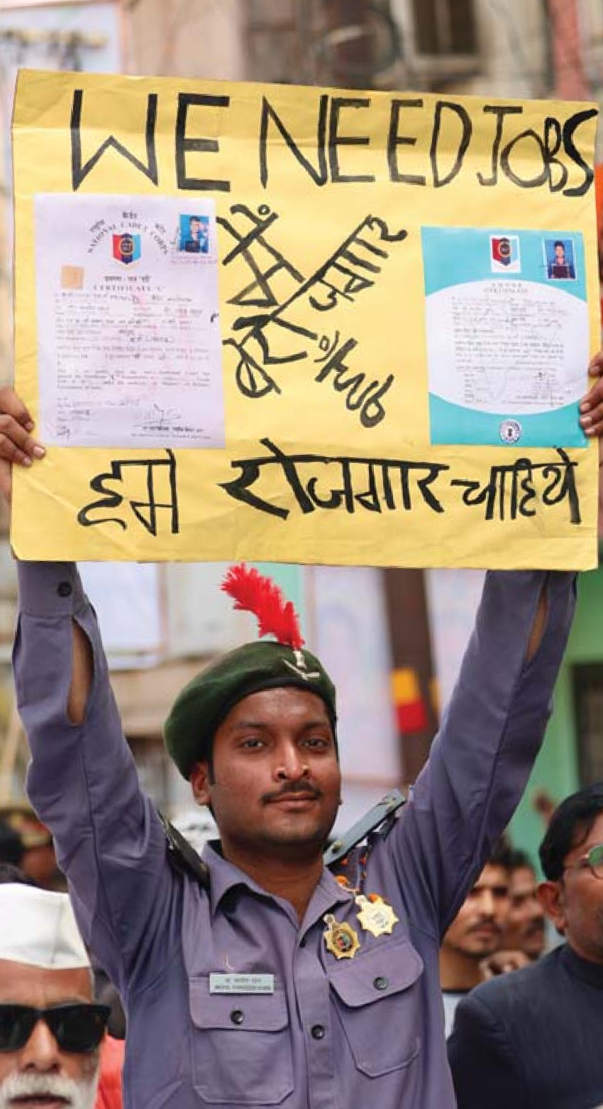
We may recall our forewarning

- We had said, “Youth have lost jobs”. The unemployment rate is 8 percent; among graduates the unemployment rate is over 40%.
- We had said, “Farmers have lost hope”. Farmers had to come on to the streets for 16 months to fight the three farm laws that would have made them tenant-farmers of corporate houses; and the farmers are back on the streets again.
- We had said, “Traders have lost business”. The Goods and Services Tax (GST) laws have squeezed exorbitant tax revenues out of lakhs of traders and constrained free trade.
- We had said, “Micro, small and medium enterprises have lost their confidence”. Lakhs of MSMEs have shut down and are no longer creators of jobs
- We had said, “Women have lost a sense of security”. Crimes against women have increased by 31 per cent between 2014 and 2022.
- We had said “Deprived communities have lost their economic rights”. Scheduled Castes (SC), Scheduled Tribes (ST) and Other Backward Classes (OBC) communities have been deprived of jobs because of the unfilled vacancies in government and other public institutions. Tribal people have been denied their rights under the Forest Rights Act.
- We had said, “Institutions have lost independence”. Every institution, including Constitutional bodies, has been undermined and, in some cases, forced to become subservient to the government.

Our greatest concern was the prevailing ‘climate of fear, intimidation and hatred’. In the last five years, every section of the people has lived in fear; laws and investigating agencies have been weaponised to intimidate people; and through its words and actions the BJP and its affiliates have spread hatred among people belonging to different religious, language and caste groups.

Today, the dangers that we had warned against have become a hard reality.

The economy is in a crisis. Despite the claim that India is the fastest growing large economy in the world, our growth rate has fallen from an average of 6.7 per cent (new series) during the UPA period of 2004-14 to an average of 5.9 per cent during 2014-24. As against the goal of doubling the economy (which the UPA did achieve), India’s GDP in real terms will rise from 100 lakh crore in 2013-14 to only 173 lakh crore in 2023-24, far short of the target.

The decline in the growth rate has serious consequences for the people, especially for those who belong to the poor and middle classes. The impact has fallen on per capita income, consumption of goods and services, and standard of living. Household net assets have declined, household liabilities have increased and families have borrowed more.

Inequality between the rich on the one hand and the poor and middle classes on the other have increased sharply dealing a body blow to the goals of equality, equity, and social and economic justice. A report titled “Income and Wealth Inequality in India, 1922-2023: The Rise of the Billionaire Raj” by leading global economists, including Thomas Piketty, shows that India under Prime Minister Narendra Modi is more unequal than even under the British Raj. The share of national income earned by India’s top 1 per cent is today at its highest historical levels and is among the highest globally. The rise of inequality has been particularly pronounced between 2014 and 2023.

The numbers of registered and active workers under MGNREGA and the fact that 80 crore people depend on free grain (5 kg per person per month) are definite indicators of widespread poverty. On the Global Hunger Index, India’s rank is 111 out of 125 countries.

The gravest danger is that India may no longer be a truly free and democratic republic. Democracy in India has been hollowed out and we are rapidly sliding to become a one-party and one-person dictatorship. The federal structure is under attack with the central government appropriating most of the central revenues, passing laws on subjects that were hitherto left to the state governments, and using its financial and executive powers to reduce states to municipalities. Governors of non-BJP-governed states are encouraged to paralyse the working of elected governments. Laws and investigating agencies are used to foist false cases against non-BJP leaders to force them to submit to the BJP’s will. The media has been rewarded or intimidated to become a vehicle of propaganda of the government.

Ask yourself two questions:
- Is your life better today than what it was in 2014?
- Is your mind without fear as dreamed by Rabindranath Tagore?
The choice is not Congress or BJP, but it is more than that. The choice is Democratic government or Authoritarian rule
Freedom or Fear
Prosperity for All or Wealth for a Few Justice or Injustice.

The 2024 general election presents an opportunity for radically changing the style and substance of gover- nance that has been in evidence in the past decade of Anyay Kaal. We appeal to you to look beyond religion, language and caste, choose wisely, and install a democratic government that will work for all the people of India. We appeal to you to vote for the INDIAN NATIONAL CONGRESS.

EQUITY

Social Justice
Congress has been the most vocal and active champion of the progress of the backward and oppressed classes and castes over the last seven decades. However, caste discrimination is still a reality. The people belonging to the SC, ST and OBC communities have not yet been able to catch up with the rest and are still left behind. While OBC, SC and ST constitute nearly 70 per cent of India’s population, their representation in high-ranking professions, services and businesses is disproportionately low. No progressive modern society should tolerate such inequality or discrimina- tion based on ancestry and the consequent denial of equal opportunity. Congress will bridge historical inequities by implementing the following programme.
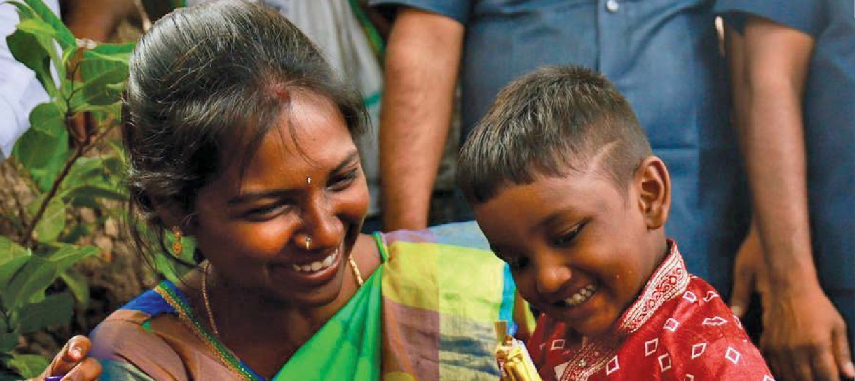

- Congress will conduct a nation-wide Socio-Economic and Caste Census to enumerate the castes and
sub-castes and their socio-economic conditions. Based on the data, we will strengthen the agenda for affirmative action.

- The Congress guarantees that it will pass a constitutional amendment to raise the 50 per cent cap on reservations for SC, ST and OBC.

- The reservation of 10 per cent in jobs and educational institutions for Economically Weaker Sections (EWS) will be implemented for all castes and communities without discrimination.

- We will fill all the backlog vacancies in posts reserved for SC, ST and OBC within a period of one year.

- Congress will abolish the contractualisation of regular jobs in the government and public sector enterprises and ensure regularisation of such appointments.
- We will enhance institutional credit to SC and ST for home-building, starting businesses and purchasing assets.

- Congress will establish an authority to monitor the distribution to the poor of government land and surplus land under the land ceiling Acts.

- The scope of the Public Procurement Policy will be expanded to award more public works contracts to contractors belonging to the SC and ST communities.

- Funds for scholarships for OBC, SC and ST students will be doubled, especially for higher education. We will aid SC and ST students to study abroad; and will double the number of scholarships for them to pursue a Ph.D.

- Congress will establish a network of residential schools for the poor, especially SC and ST students, and extend them to every block.

- We will include in the curriculum of schools the life and work of social reformers to spread the message of social justice.

- We will establish Ambedkar Bhavans-cum-Libraries in every district to promote the habit of reading and discussion.

- We will enact a law with reference to Article 15(5) of the Constitution to provide for reservation in private educational institutions for SC, ST and OBC.

- We will pass a law authorising allocation of resourc- es for the Scheduled Caste Sub Plan and Tribal Sub Plan within the annual budget and monitoring the execution of the plans.

- Congress will end the evil of manual scavenging. Every manual scavenger will be rehabilitated, re-skilled, provided a job and assured a life of dignity and safety. The Prohibition of Manual Scavenging Act, 2013, will be strictly implemented and any person employing anyone for manual scavenging shall be punished. We will provide compensation of 30 lakh to families of sanita- tion workers (safai karamcharis) deceased while at work. We will allocate sufficient funds to enable the procurement of machines that will clean sewers and septic tanks, and remove human waste. Free insurance will be provided to all sanitation workers.

- The Scheduled Castes and the Scheduled Tribes (Prevention of Atrocities) Act, 1989 will be enforced diligently. A helpline will be established in every State’s capital and legal aid and paralegal support will be provided to the victims of such atrocities.

- Congress is committed to notify as ‘Scheduled Area’ all habitations or groups of habitations where ST are the largest social group outside the present Sched- uled Areas in all States and Union Territories.

- A national mission will be set up for effective implementation of the Forest Rights Act, 2006 through a dedicated FRA division, a separate budget and action plans.

- The Congress will ensure settlement of all pending FRA claims within 1 year and establish a process for review of all rejected claims within 6 months.

- Congress is committed to ensure that states enact laws in conformity with the framework of the central Panchayats (Extension to Scheduled Areas) Act, 1996 (PESA) to establish 'Village Council’ and 'Autonomous District Council’ as envisaged in PESA.

- We will enact the Rohith Vemula Act to address discrimination faced by students belonging to the backward and oppressed communities in educational institutions.

- We will implement the recommendations of the Renke Commission. We will provide free education for children belonging to the Nomadic Tribes and De-noti- fied Tribes.
RELIGIOUS AND LINGUISTIC MINORITIES
The plurality of religions represents the history of India. History cannot be altered. All people living in India and all children born in India are equally entitled to enjoy human rights that includes the right to practise one’s religion. Pluralism and diversity constitute the ethos of India and are enshrined in the Preamble to the Constitution of India. Given the history and the democratic traditions of India, the Congress believes that there is no place for authoritarianism or majoritari- anism.

Linguistic and religious minorities are granted human and civic rights under the Constitution of India. Congress pledges to uphold and protect these rights.

- Congress will establish a Diversity Commission that will measure, monitor and promote diversity in public and private employment and education.

- We will respect and uphold the fundamental right to practice one’s faith and the rights guaranteed to religious minorities under Articles 15, 16, 25, 26, 28, 29 and 30 of the Constitution.

- We will also respect and uphold the rights of linguis- tic minorities guaranteed under Articles 15, 16, 29 and 30 of the Constitution.

- We will encourage and assist students and youth belonging to the minorities to take full advantage of the growing opportunities in education, employment, business, services, sports, arts and other fields.

- We will restore the Maulana Azad Scholarships for study abroad and increase the number of scholarships.

- The economic empowerment of minorities is a necessary step for India to realise its full potential. We will ensure that banks will provide institutional credit to minorities without discrimination.
- We will ensure that the minorities receive their fair share of opportunities in education, healthcare, public employment, public works contracts, skill development, sports and cultural activities without discrimination.

- Congress will ensure that, like every citizen, minori- ties have the freedom of choice of dress, food, language and personal laws.

- We will encourage reform of personal laws. Such reform must be undertaken with the participation and consent of the communities concerned.

- Congress promises to meet long standing demands for inclusion of more languages in the Eighth Schedule of the Constitution.

SENIOR CITIZENS, PERSONS
WITH DISABILITIES, AND LGBTQIA+

- The central government’s contribution to pensions for senior citizens, widows and persons with disabilities under the National Social Assistance Programme remains a pitiful 200 - 500 per month. Congress will raise this amount to 1,000 per month.

- We will take measures to ensure easy access to legal services for senior citizens especially in cases of neglect, abuse, abandonment, eviction and financial fraud.

- Congress will review the Maintenance and Welfare of Parents and Senior Citizens Act, 2007, remove the deficiencies and enforce the Act.

- We will restore travel concessions in public transport (rail and road) for senior citizens.

- We will expand Articles 15 and 16 of the Constitution to prohibit discrimination on the ground of ‘disability’, ‘impairment’ or ‘sexual orientation’.
- We will recognise the Braille script and Sign Language as languages.

- We will establish a National Centre of Research and Excellence for Special Education to ensure that quality education is imparted to children with special needs and children with disabilities.

- As was done in Chhattisgarh, Congress will provide representation for persons with disabilities in local government bodies.

- We will strictly enforce the Rights of Persons with Disabilities Act, 2016.

- We will implement a scheme to establish Assisted Living and Care Centres for the disabled in public-pri- vate partnership throughout the country.

- After wide consultation, Congress will bring a law to recognize civil unions between couples belonging to the LGBTQIA+ community.

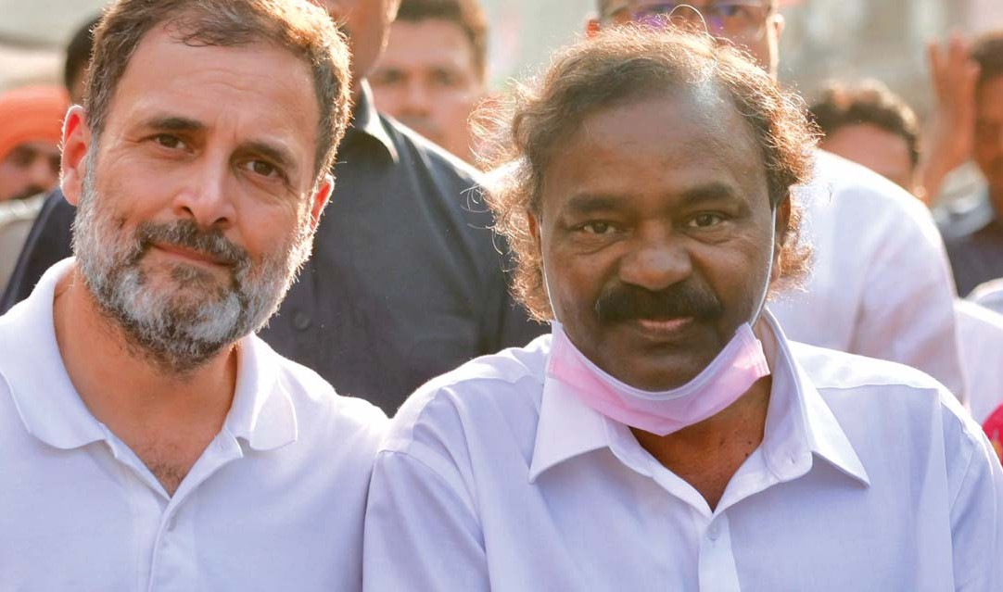

HEALTH
Congress was the first political
party to acknowledge that health of the people and healthcare are the responsibility of the govern- ment. Congress introduced the first healthcare scheme in India and firmly believes that all citizens have the Right to Health.

- We promise that healthcare will be universal and free in public health centres such as hospitals, clinics, primary health centres, mobile healthcare units, dispen- saries and health camps. Free healthcare will include examination, diagnostics, treatment, surgery, medicines, rehabilitation and palliative care.
- The Rajasthan Model of cashless insurance up to
25 lakhs will be adopted for universal healthcare.

- Primary Health Centres (PHC) will be upgraded according to Indian Public Health Standards norms, and diagnostics will be added in each PHC.

- We will encourage the introduction of health insurance schemes in the private sector and public sector. The current universal healthcare programme will be redesigned for different sections of the people and will allow enlistment of private hospitals, non-profit health facilities and health centres under the schemes.

- Maternity benefits will be available to all women. All employers shall mandatorily grant paid maternity leave for their employees.

- Budget allocation for Health will be increased step by step every year to achieve 4 per cent of total expenditure by 2028-29.

- Congress will double the hardship allowance of doctors serving in rural areas, and provide suitable residence facilities.

- The contribution of the Central government to the pay of frontline health workers (such as ASHA,
Anganwadi, Mid-Day Meal cooks, etc.) will be doubled.

- We will establish one government medical college-cum-hospital in each district.

- All vacancies in medical and paramedical posts in public health institutions and all vacancies in medical colleges will be filled in three years.

- No hospital or medical college shall be permitted to be opened or allowed to function unless 75 per cent of the medical, paramedical and teaching posts are filled.
- The National Medical Commission Act shall be reviewed, and the anomalies and deficiencies removed. NMC shall enjoy full autonomy to carry out the obliga- tions under the Act.

- A second ASHA will be appointed in villages with a population of over 2,500.

- All systems of medicine will be supported by the government.

- All manufacturers of medicines will be under strict scrutiny for maintaining quality and following good manufacturing practices.

- The number of central government dispensaries will be rapidly expanded. All central government dispensaries will dispense brand and generic medi- cines of good quality at reasonable prices.

- A National Mission on Immunisation will be taken up. Only 76 per cent of Indian children receive full immunisation. Congress will ensure full immunisation of 100 per cent of children within 5 years.

- Nutritional deficiency among children will be addressed to rapidly reduce the incidents of stunting and wasting. We will expand the mid-day meal scheme up to Class XII.

- Congress will pass a law making it an offence to commit acts of violence against doctors and other health professionals while performing their duties.

YOUTH

Jobs
“The future lies in the youth of today” is particularly relevant for a young nation like India with a median age of just 28 years. The youth of India face joblessness as well as hopelessness. The root cause is massive unemployment that has got worse every year under the BJP/NDA government. Congress will tackle this issue on a war footing with a clear Yuva Nyay programme.
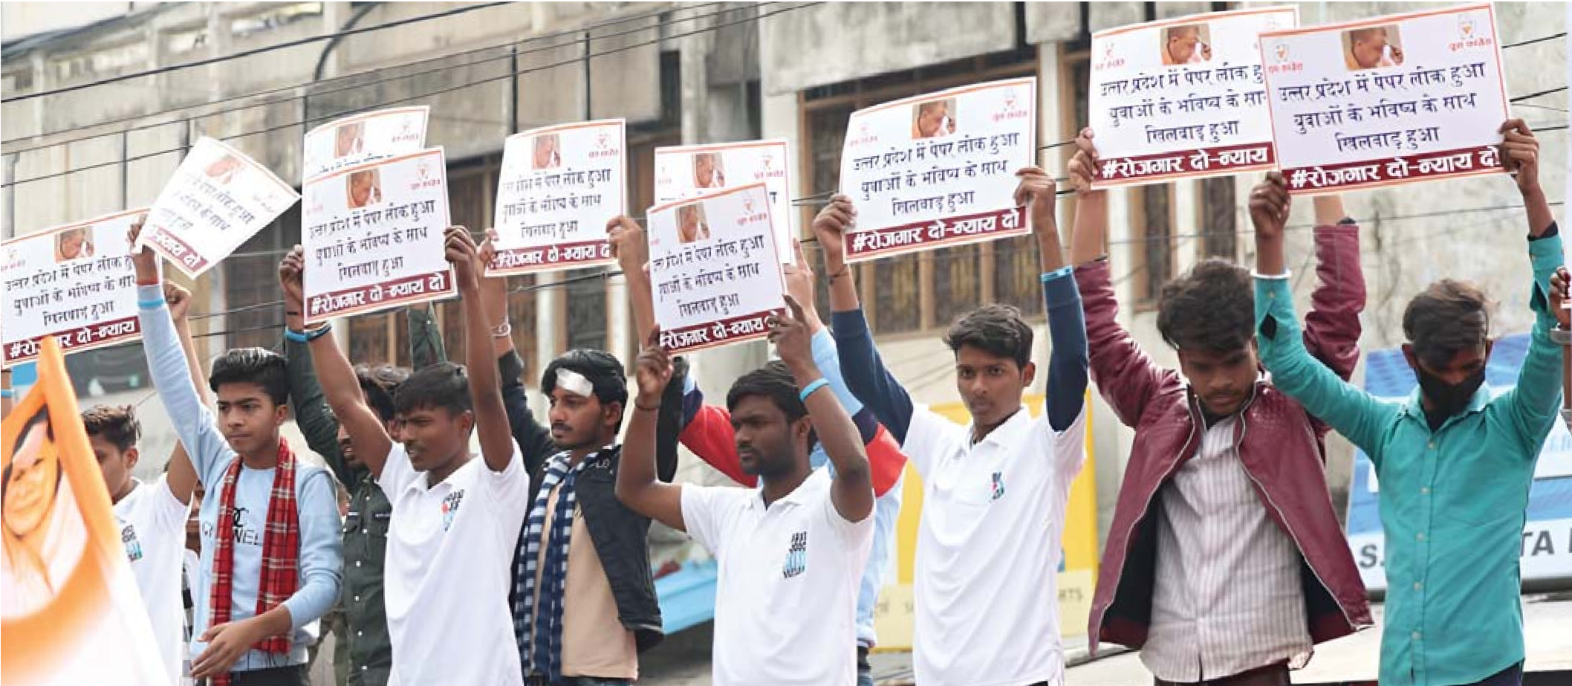

- Congress guarantees a new Right to Apprenticeship Act to provide a one year apprenticeship with a private or a public sector company to every diploma holder or college graduate below the age of 25. Apprentices will get 1 lakh a year. The apprenticeship will impart skills, enhance employability and provide full-time job opportu- nities for millions of youth.

- We will provide fast-track courts to adjudicate cases of leaking question papers for job examinations and provide monetary compensation to the victims.

- We will fill the nearly 30 lakh vacancies in sanctioned posts at various levels in the central government. We will stipulate that vacancies in the
panchayats and municipal bodies shall be filled accord- ing to a timetable agreed with state governments.

- Congress will restructure the Fund of Funds Scheme for start-ups and allocate 50 per cent of the available fund, as far as possible equally among all districts, for providing funds to youth below 40 years of age to start their own businesses and generate employment.
- Government will give a one-time relief to applicants who were unable to write the qualifying public exam- inations during 1 April 2020 to 30 June 2021 due to the pandemic.

- We will abolish application fees for government examinations and government posts.

- Due to widespread unemployment, as a one-time measure of relief, the amount due including unpaid interest as on 15 March 2024 in respect of all student educational loans will be written off and the banks will be compensated by the government.

- Congress will provide sports scholarships of
10,000 per month for talented and budding sportsper- sons below the age of 21.

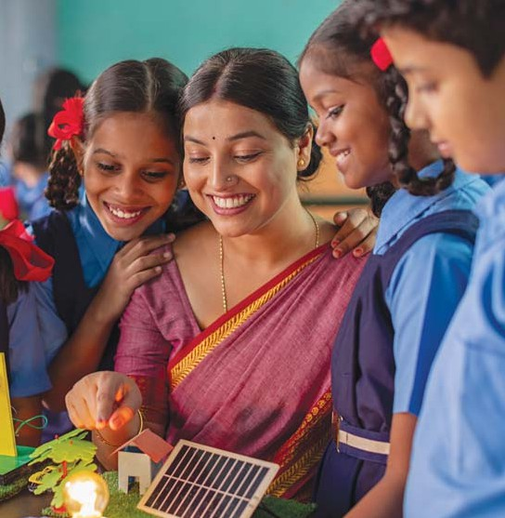

EDUCATION
Education is a public good and every student has the right to free, quality education provided by the state. Schools, colleges and universities should be predominantly public institutions funded by public resources. We recognise that private educational institutions play an important supplementary role.

- Congress brought in the Right to Education (RTE) Act in 2009 that transformed education for children between the ages of 6 and 14. We will amend the RTE Act to make education from Class I to Class XII in public schools compulsory and free.

- The New Education Policy (NEP) announced by the BJP/NDA government has been opposed by education- ists and several state governments. Education is a concurrent subject and the rights of states to formulate an education policy must be respected. Hence, we will revisit and amend the NEP in consultation with the state governments.

- We will end the practice of charging special fees for different purposes in public schools.

- For greater equity, affordability and transparency in school fees charged by private schools, we will encour- age state governments to establish fee regulation committees.

- The quality of teaching is the most important deter- minant of educational outcomes. Congress will work with states to ensure that every class and every subject has a dedicated teacher. Each class must have a dedicated classroom.

- Foundational learning emphasising literacy, numera- cy, foundational science and Constitutional values in schools is an important requirement for all children. Congress will expand the budget for and scale up government programmes for foundational learning.
- School and college syllabuses will emphasise the study of STEM subjects in order to develop a scientific temper.

- We will discourage the use of teachers for non-teaching activities.

- We will discourage the appointment of contractual teachers in regular vacancies and ensure that such appointments are regularised.

- We will accelerate the integration of pre-primary and primary education to ensure that all children receive at least two years of pre-school education.

- Annual surveys have revealed the huge gaps in learning outcomes in school education. We shall take urgent measures to address these deficiencies and ensure wholesome learning outcomes within a period of 5 years.

- Congress will increase the number of Kendriya Vidyalayas, Navodya Vidyalayas and Kasturba Gandhi Balika Vidyalayas in consultation with the State Governments.

- We will restore the autonomy of colleges and universities. Higher educational institutions will have academic freedom and will be encouraged to experi- ment, innovate and promote research. We will protect and preserve students’ freedom of speech and expres- sion and the right to have elected student unions.

- To reduce dropout rates, we will ensure that pre-ma- tric and higher education scholarships for disadvan- taged groups including SC, ST, OBC, EWS, denotified tribes and minorities are restored, increased and fully funded.

- We will ensure that all central textbooks promote a scientific temper and are aligned with India’s constitutional values as contained in the Preamble and other provisions of the Constitution of India. Textbook revisions will not be done arbitrarily or driven by political motives.

- We will assist state governments to establish one Government Community College in every tehsil/taluk for students completing Class XII. These community colleges will offer a broad range of degrees/diplomas suitable for jobs in the service industry (e.g. hospitality, tourism, digital marketing, paramedical, paralegal, etc.) and for jobs in the manufacturing industry that require basic technical skills.

- Congress will revive the Education Loan programme to college students implemented under the UPA govern- ment and instruct banks to extend collateral-free education loans up to 7.5 lakhs especially to students belonging to the SC, ST, OBC, EWS and minorities.

- Due to widespread unemployment, as a one-time measure of relief, the amount due including unpaid interest as on 15 March 2024 in respect of all student educational loans will be written off and the banks will be compensated by the government.

- Congress will ensure that serving teachers are represented in the governing bodies of colleges and universities.
- We will fill all teaching and non-teaching vacancies in central universities and other central educational institutions.

- National accreditation bodies will be strengthened and higher educational institutions will be accredited based on stringent quality norms.

- Online courses and digital learning have gained importance. We will ensure that all students of classes IX to XII have mobile phones to ensure equitable access to learning. We will provide free and unlimited Internet on college and school campuses to increase accessibility and connectivity.

- We will ensure that all coaching centres and EdTech companies meet stringent quality standards.

- We will ensure that all higher educational institu- tions — central, state and private — meet the prescribed standards for admitting students. We will revisit the policy of centrally-conducted qualifying examinations such as NEET, CUET, etc. and make it optional for state governments to adopt these exam- inations for admissions or conduct their own examina- tions meeting the prescribed standards to state-funded and state-approved higher educational institutions.

- We will assist state governments to establish state-of-the-art Internet-enabled public libraries in state, district and taluk headquarters.

SPORTS
No government in India’s independent history has politicised sports as much as the present BJP/NDA government. From scheduling World Cup games in select venues for overt political purposes to turning a blind eye to harassment of India’s Olympians by politically-aligned persons in sports bodies, Indian sports is arguably going through its worst phase.
Congress believes that Indian sport will soar only when the autonomy of sports bodies is restored, political bias is removed, and the government is a strong and neutral supporting force for sports development.

- Congress will take suitable measures to ensure that the constitution of each sports body is in accordance with certain norms and principles, that elections are held according to the constitution of that body and the recommendations of the Justice Lodha Committee, and that there is adequate representation in each sports body for active players, former players and women.

- Congress will enact a separate legislation for the registration of sports federations/bodies/associations which will ensure full compliance with the Olympic Charter, allow for autonomy and full accountability, and provide recourse for members and sportspersons against discrimination, bias, sexual harassment, abuse, wrongful termination, etc.

- Congress will provide sports scholarships of 10,000 per month to talented and budding sports persons below the age of 21.

- Congress will ensure that there is at least one community sports centre in every block and municipal town and at least one multi-sport coaching centre in every district.

- We will establish a National Sports Science Institute to promote research and development in sports scienc- es and training.

- In order to encourage talented youth to pursue sports as a profession without fear of their future, Congress will introduce a “Sporting Heroes Job Guar- antee” programme to assure every sportsperson who has represented India at the international level or the national level a good quality job after the end of the sportsperson’s sporting career.

- We will allocate sufficient funds to promote sports among girls and women, persons with disabilities, and disadvantaged groups such as ST.

WOMEN

Mahalakshmi
Inequality of income and opportunity remains India’s ugliest truth. It is the moral and political responsibility of any government to ensure that every Indian family is assured of a basic income every month.
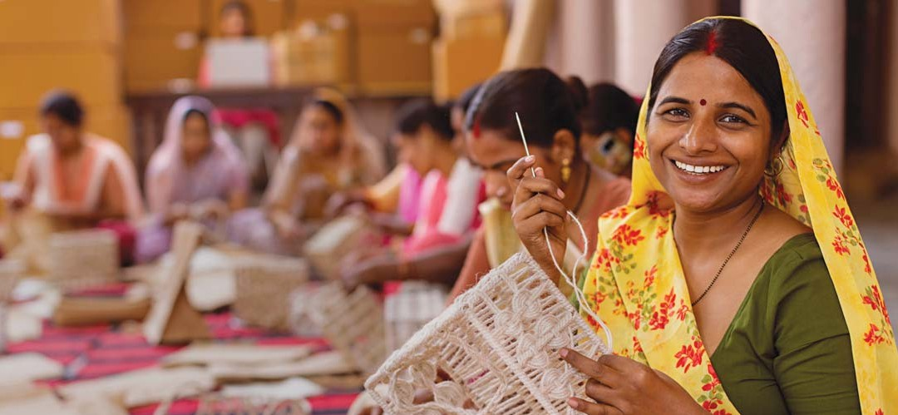

- Congress resolves to launch a Mahalakshmi scheme to provide 1 lakh per year to every poor Indian family as an unconditional cash transfer. The poor will be identified among the families in the bottom of the income pyramid.

- The amount will be directly transferred to the bank account of the oldest woman of the household.
Absent a woman, it will be transferred to the account of the oldest member of the family.

- The scheme will be rolled out in stages and reviewed every year to assess the number of
beneficiary families and its impact on alleviating poverty.

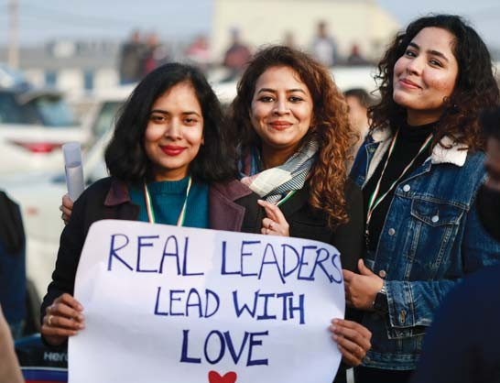
WOMEN ‘S EMPOWERMENT
Historically, women have been
discriminated against and put at great disadvantage.
Congress pledges to remove the discrimi- nation against women and uphold and advance the rights of women.

- The Constitution (106th) Amendment Act marks the BJP’s great betrayal of women. The Amendment Act contains sinister provisions that will allow the reserva- tion of seats in the Lok Sabha and State Assemblies to come into operation only beyond 2029. Congress will delete the sinister provisions and bring the Amendment Act into force immediately. The one-third reservation for women will be applied to State Assemblies that will be elected in the next round of Assembly elections in 2025. The one-third reservation for women will also be applied to the Lok Sabha that will be elected in 2029.

- We will reserve one-half (50 per cent) of central government jobs for women starting in 2025.

- We will ensure that more women are appointed to high positions such as judges, secretaries to govern- ment, high ranking police officers, law officers and directors on the boards of listed companies.

- All laws will be scrutinised for gender discrimination and gender bias. The offending provisions will be
- We will ensure that laws intended to prevent offences against women such as the Sexual Harass- ment of Women at Workplace (Prevention, Prohibition and Redressal) Act, 2013 and the Protection of Women from Domestic Violence Act, 2005 are strictly enforced.

- The government will fund state governments to build sufficient night shelters for migrant women workers and adequate number of safe and hygienic public toilets for women will be provided in towns and cities. Free napkin vending machines will be installed in public spaces, schools and colleges.

- In partnership with the State governments, the Central Government will double the number of working women hostels in the country, with at least one Savit- ribai Phule Hostel in each district.

- We will appoint an Adhikar Maitri in every Pancha- yats to serve as a paralegal to educate women and assist them in the enforcement of their legal rights.

removed or amended in the first year of the Congress government.

- We will ensure that the principle of ‘Same Work, Same Wages’ is enforced in order to prevent discrimination in wages for women.

- The contribution of the Central government to the pay of frontline health workers (such as ASHA, Anganwadi, Mid-Day Meal cooks, etc.) will be doubled.

- We will substantially increase the amount of institu- tional credit that is extended to women. In particular, we will vastly enhance the credit extended to Self Help Groups by banks, Non-Banking Financial Companies and Micro Finance Institutions.

- The Labour Force Participation Rate of women is an abysmal 25 per cent. We will embark on a massive exercise to expand women’s participation in the work- force through measures such as fair and equal wages; safe places of work; childcare services; preventing
sexual harassment and violence; and extending materni- ty benefits.

- We will re-incorporate the Bhartiya Mahila Bank (Women’s Bank) that had made a promising start under an all-Women Board of Directors but was wound up by the patriarchal BJP/NDA government.

- In matters of marriage, succession, inheritance, adoption, guardianship, etc., women and men should have equal rights. We will review all the laws and ensure equality between men and women.

FARMERS
The farmers’ agitations ring the alarm bells to the deep crisis in the agriculture sector.

The BJP/NDA government’s response has been callous and brutal. Farmers do not get fair and remunerative prices for their produce; nor do the producers have adequate avenues to market their produce. Export controls have debili- tated farmers. The plight of farm labourers is worse; the work available is irregular and the wages have stagnated for nearly four years.

Agriculture
Congress is the only party that has lent its ear to the distress call of the farmers and farm labour and we are determined to do everything possible to alleviate their pain and make agriculture a desirable livelihood.
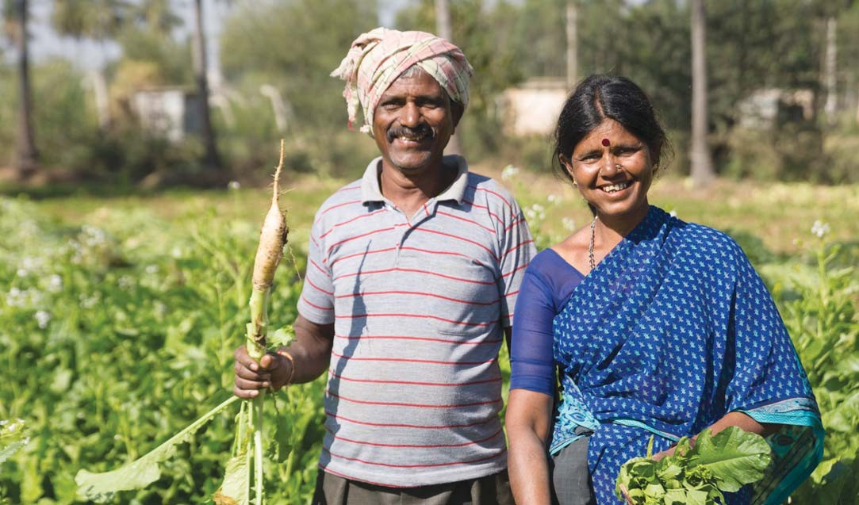

- Congress will give a legal guarantee to the Minimum Support Prices (MSP) announced by the government every year, as recommended by the Swaminathan Commission.

- The Commission for Agricultural Costs and Prices (CACP) will be made a statutory body.

- MSP payable to the farmer-seller at the procurement centres and APMCs will be directly credited digitally to the bank account of the farmer.
- We will appoint a Permanent Commission on Agricultural Finance that will report periodically on the extent of agricultural credit and the need for loan forbearance.

- Crop insurance will be made farm and farmer specific. Premium will be charged from the farmer according to the sum insured and all claims will be settled within 30 days.

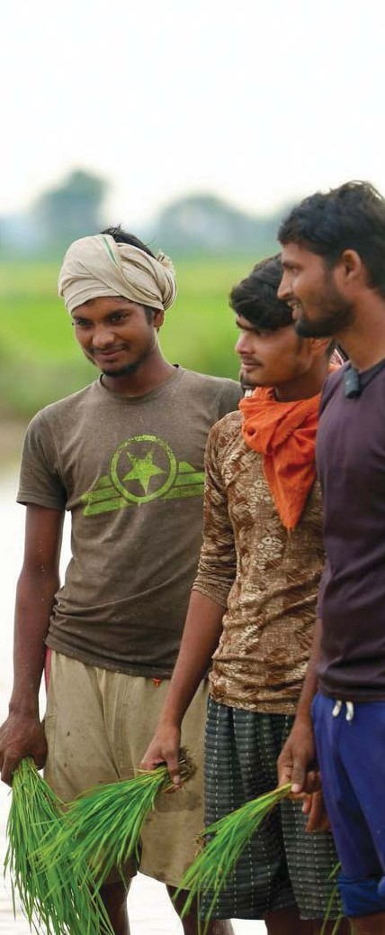
- In consultation with farmers’ organizations, we will make available to farmers three avenues for sale of agricultural produce:
  - Regulated Market under the prevailing APMC Act.
  - E-market that will be operated by an autonomous body with representation of farmers’ organizations, Farmer-Producer Organizations (FPOs) and individual progressive farmers.
  - Freedom to the farmer to sell agricultural produce at the farm-gate or at any other place of choice with an option to upload the sale-and-purchase agreement on a digital ledger.

- We will establish farmers’ retail markets in large villages and small towns to enable the farmers to bring their produce and sell the same to consumers.

- Congress will formulate and implement a sound import-export policy for agricultural commodities, which will give paramount importance to protecting the interests and concerns of farmers.

- We will revive the system of Agricultural Extension Services to disseminate the best knowledge and best practices to every agricultural holding. We will increase the number of Krishi Vigyan Kendras and appoint more scientists to each Kendra.

- We will launch a major programme to install solar panels connected to tube wells to generate energy.

- Congress will implement a major initiative to promote horticulture, pisciculture and sericulture, and encourage farmers to diversify into these activities and increase their income.

- We will double the value of the output in dairying and poultry in five years.

- In co-ordination with state governments, we will ensure that one agricultural college and one veterinary college is established in every district of the country.

- We will double the funding for R&D in agriculture in five years.

FISHERIES AND FISHING COMMUNITIES

- We will restore the subsidy for diesel for sea-going fishing communities.

- We commit to expeditious search for fisherfolk missing at sea. If presumed dead, death certificates will be issued within 3 months.

- We will direct insurance companies to provide insurance cover for sea-going fishing boats.

- Fishing communities will be issued credit cards (like Kisan Credit Cards) by banks and extended credit.

- Fishing communities will be enumerated in the caste census and given identity cards by the Central Govern- ment.

- Inland fishing and aquaculture will be recognized as ‘agriculture’.

- Congress will promote phytosanitary standards and the exports of marine products that meet such standards.
- Fishing harbours will be developed along the coast line for the use of the fishing community.

- We will create cooperative banks for fishing communities.

- Congress will establish mechanisms with neigh- bouring countries to resolve the problems faced by fishing communities, to eliminate conflict, arrests, seizure of boats and loss of lives, and to improve livelihood opportunities for our fishing communities.

WORKERS

- We will introduce reforms in industrial and labour laws to restore the balance between labour and capital to meet our twin goals of full employment and high productivity gains.

- We will address the issues of gender discrimination and gender inequality in workplaces and in accessing economic opportunities.

- We will ensure that the principle of ‘Same Work, Same Wages’ is enforced in order to prevent discrimination in wages for women.

- We will increase the wage under MGNREGA to 400 per day. MGNREGA funds and workers may also be deployed to build public assets such as classrooms, libraries and primary health centres.

- We will launch an urban employment programme guaranteeing work for the urban poor in reconstruction and renewal of urban infrastructure.

- We will make a law to specify and protect the rights of gig workers and unorganised workers and enhance their social security.

- We will propose laws to regulate the employment of domestic help and migrant workers, and ensure their basic legal rights.
- The list of ration card holders will be updated in all States immediately and it will be ensured that all ration card holders, including migrant workers, get their rations regularly.

- We will expand the PDS coverage based on updated population figures (pending the Census). PDS will include pulses (dal) and cooking oil.

- Sufficient funds will be allocated to PDS, ICDS and the Mid-day Meal Scheme to fulfil the mandate of the National Food Security Act, 2013.

- We will collaborate with the state governments to open Indira Canteens that will offer subsidised meals as has been done in Karnataka and Rajasthan.

- Appoint a second ASHA worker in all villages with a population exceeding 2,500 persons.

- Double the number of Anganwadi workers and create an additional 14 lakh jobs.

- The Congress guarantees a national minimum
wage at Ɵ400 per day.

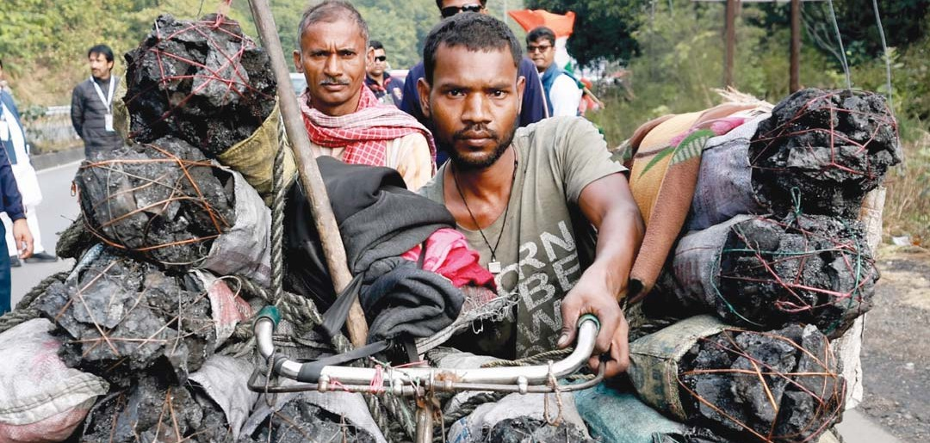

DEFENDING THE CONSTITUTION
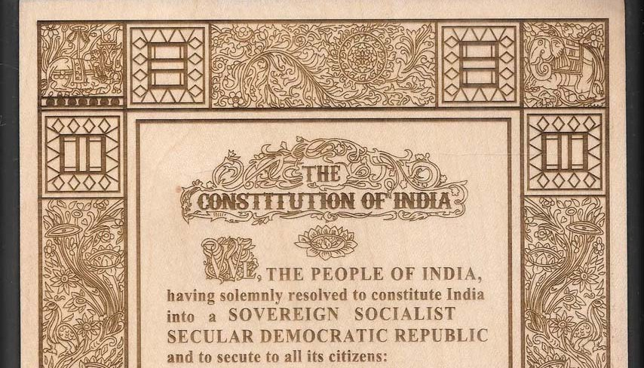

Saving Democracy, Removing Fear, Restoring Freedom
India’s democracy has been reduced to an empty shell. Every institution, including Parliament, is perceived to have lost its independence and become subservient to the executive government. It is common knowledge that it is the will of one person that prevails in the country. People’s trust in democratic institutions will be restored.

- We promise you freedom from fear.

- We promise to restore freedom of speech and expression including full freedom of the media.

- We promise to de-criminalise the offence of defama- tion and provide, by law, a speedy remedy by way of civil damages.

- We promise to end the arbitrary and indiscriminate suspension of the Internet.

- We will review the Telecommunications Act, 2023 and remove the provisions that restrict freedom of speech and expression and that violate the right to privacy.

- We promise to review all laws that interfere with the right to privacy and make suitable amendments to various laws to uphold the right to privacy.
- We promise to uphold the people’s right to assemble peacefully and to form associations.

- We promise not to interfere with personal choices of food and dress, to love and marry, and to travel and reside in any part of India. All laws and rules that interfere unreasonably with personal freedoms will be repealed.

- We promise that the two Houses of Parliament will each meet for 100 days in a year and the great traditions of Parliament that prevailed in the past will be revived and scrupulously observed. We promise that one day in a week will be devoted to discuss the agenda suggested by the opposition benches in each House. We promise that the presiding officers of the two Houses will be required to sever their connection with any political party, remain neutral, and observe the age-old norm that the ‘Speaker does not speak’.

- We reject the ‘one nation one election’ idea and we promise that elections to the Lok Sabha and the State Assemblies will be held as and when they are due in accordance with the Constitution and the traditions of a parliamentary democracy.

- We promise to restore the voters’ trust in the election process. We will amend the election laws to combine the efficiency of the electronic voting machine (EVM) and the transparency of the ballot paper. Voting will be through the EVM but the voter will be able to hold and deposit the machine-generated voting slip into the voter-verifiable paper audit trail (VVPAT) unit. The electronic vote tally will be matched against the VVPAT slip tally.

- We promise to strengthen the autonomy of the Election Commission of India, the Central Information Commission, the Human Rights Commission, the office of the Comptroller and Auditor General, the Commis- sions for SC, ST, minorities and OBC, and other constitu- tional bodies.

- We promise to amend the Tenth Schedule of the Constitution and make defection (leaving the original party on which the MLA or MP was elected) an automat- ic disqualification of the membership in the Assembly or Parliament.
- We promise to restore the Planning Commission and define its role and responsibilities that will include formulating medium and long-term perspective plans to meet the needs of the Nav Sankalp Economic Policy described in Chapter VII.

- We promise to ensure that the police, investigation and intelligence agencies will function strictly in accordance with law. They will be brought under the oversight of Parliament or the state legislatures, as the case may be.

- We promise to put an end to the weaponisation of laws, arbitrary searches, seizures and attachments, arbitrary and indiscriminate arrests, third-degree methods, prolonged custody, custodial deaths, and bulldozer justice.

- We promise to enact a law on bail that will incorpo- rate the principle that ‘bail is the rule, jail is the excep- tion’ in all criminal laws.

- We will introduce comprehensive prison reform to transform jails into institutions of rehabilitation, reform and correction.

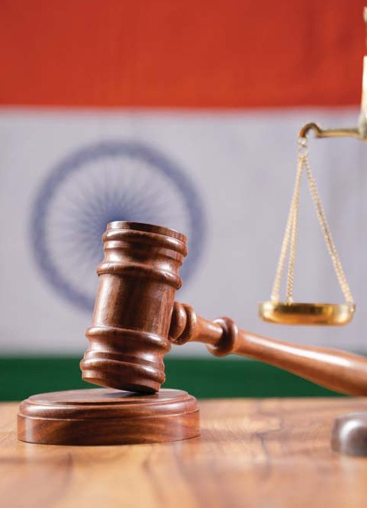
REVERSING THE DAMAGE
In the last 10 years tremendous damage was done by the BJP/NDA by misusing the brute majority enjoyed by it in Parliament to make laws that violated the letter and spirit of the Constitution of India as well as the fundamental principles of
law-making, namely, necessity, consultation, reasonableness and proportionality.

We promise that all anti-people laws passed by the BJP/NDA without proper parliamentary scrutiny and debate, especially those relating to workers, farmers, criminal justice, environment & forests and digital data protection, will be thoroughly reviewed and changed.

We will carry out complete investigations of the Electoral Bonds Scam, the reckless sale of public assets, the PM CARES scam, repeated intelligence failures at the highest levels and corruption in major defence deals.

MEDIA
In the last ten years, significant sections
of the media have been robbed of, or surrendered, their freedom. Congress will help the media re-discover the freedom that they enjoy under the Constitution.

- Congress has always believed that self-regulation is the best way to correct the misuse of the media. Congress will amend the Press Council of India Act, 1978 to strengthen the system of self-regulation, protect journalistic freedoms, uphold editorial independence and guard against government interference.

- Congress will amend the Press Council of India Act, 1978 to empower the Council to deal with the menace of fake news and paid news.

- Congress will defend independent journalism by enacting laws to protect journalists from coercive action by the State. This includes restricting the powers of the government for surveillance of journalists, seizure of their devices and exposure of their sources.

- Congress will pass a law to curb monopolies in the media, cross-ownership of different segments of the media, and control of the media by business organisa- tions. Congress will refer cases of suspected monopo- lies to the Competition Commission of India.
- All media houses, irrespective of the size, will be required to disclose their ownership structures (direct and indirect), cross holdings, revenue streams, etc. through their websites.

- Congress will pass a law to preserve the freedom of the Internet and to prevent arbitrary and frequent shutdowns of the Internet.

- Many new laws (e.g. the Broadcasting Services (Regulation) Bill, 2023; Digital Personal Data Protection Act, 2023; Press and Registration of Periodicals Act, 2023, etc.) give unbridled powers of censorship to the government. The first named Bill will be withdrawn. The restrictive provisions of the two Acts will be amended or deleted to eliminate backdoor censorship.

- Congress will amend the Cinematograph Act, 1952 to provide that the Central Board of Film Certification grants graded certificates to according to transparent and reasonable criteria.

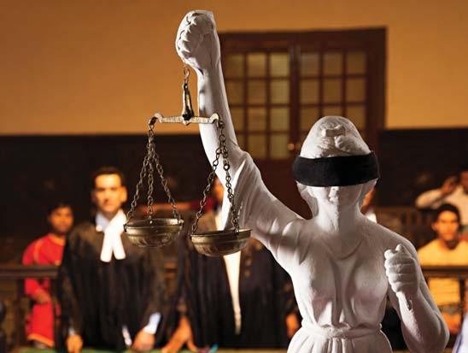
JUDICIARY
Thanks to the misgovernance, weaponisation of
the laws, misuse of investigating agencies and abuse of executive powers by the BJP/NDA government in the last 10 years, the people have come to look upon the judiciary as the last bastion against anti-democratic actions and authoritarianism. An independent judiciary alone can uphold the Constitution of India.

- The independence and quality of the judiciary is reflected in the independence and quality of the judges. Congress will unswervingly uphold the independence of the judiciary. In consultation with the Supreme Court and the Chief Justices of the High Courts, Congress will establish a National Judicial Commission (NJC). The composition of the NJC will be decided in consultation with the Supreme Court. The NJC will be responsible for the selection and appointment of judges of the High Courts and the Supreme Court.

- All vacancies in the High Courts and Supreme Court will be filled within three years.

- Congress will amend the Constitution to create two divisions in the Supreme Court: a Constitutional Court and a Court of Appeal. The Constitutional Court consist- ing of the seven seniormost judges will hear and decide cases involving the interpretation of the Constitution and other cases of legal significance or national impor- tance. The Court of Appeal will be the final court of appeal that will, sitting in Benches of three judges each, hear appeals from the High Court and National Tribu- nals.
- We will allocate sufficient funds for augmenting the physical and technical infrastructure of the judiciary and for the modernisation and maintenance of the infrastructure.

- More women and persons belonging to the SC, ST, OBC and minorities will be appointed as judges of the High Courts and the Supreme Court.

- Congress will establish a Judicial Complaints Commission consisting of retired judges of the Supreme Court and retired Chief Justices of the High Courts to investigate complaints of misconduct against judges of the higher judiciary.

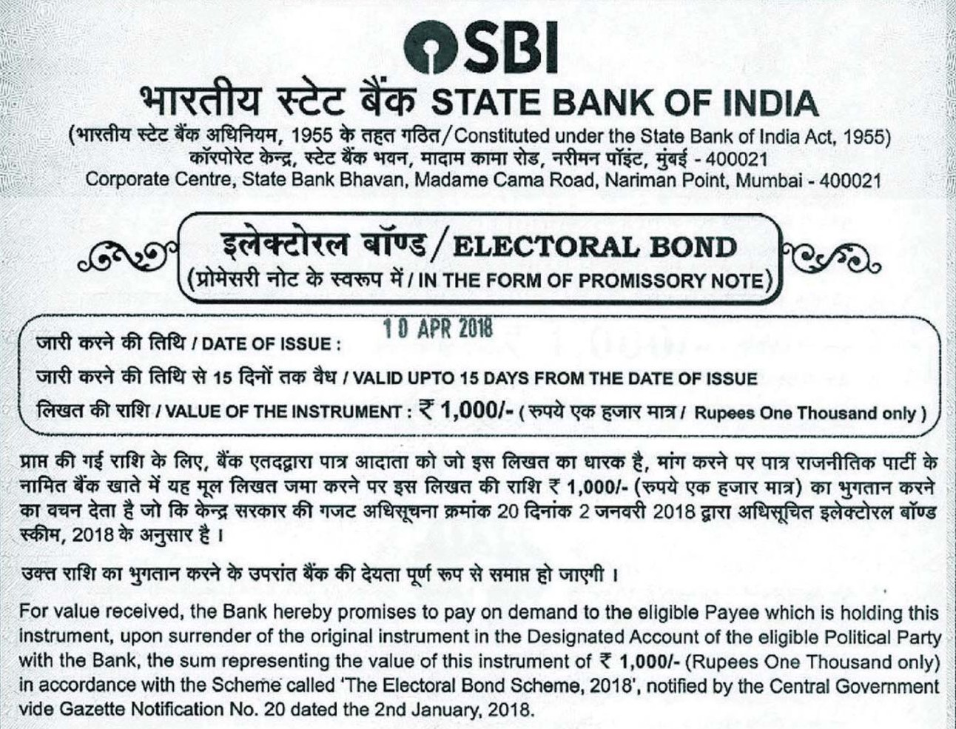
ANTI-CORRUPTION
In the last 10 years, we have seen that several measures taken by the BJP/NDA government were actually a cloak for corruption. Some examples are demonetisation, the Rafale deal, Pegasus spyware, and the Electoral Bonds scheme. Congress will probe these dubious deals and schemes and bring to law those who made illegal gains through these measures.

Known offenders were allowed to leave the country in the last 10 years. The BJP/NDA government is perceived to have facilitated their leaving the country and has not been able to bring back any of the scamsters. The circumstances under which they were allowed to leave the country will be probed and all scamsters and their accomplices will be brought before the law.

The BJP has turned out to be a giant washing machine. Accused in registered cases who joined the BJP were allowed to escape the law. The allegations against such persons will be revived and investigated.

ART, CULTURE AND HERITAGE
Art, culture and heritage constitute the identity of a people. The BJP/NDA government has focused on looking at culture through the lens of politics and ideology, while the actual practitioners, practices and institutions of culture have been neglected or actively undermined. Congress is committed to protect the rich diversity of India’s art and culture and to ensure they thrive in an atmo- sphere of freedom and creativity.

- Congress will guarantee artistic freedom. We will oppose censorship. Attempts by vigilante groups to censor or intimidate artists will be dealt with firmly and according to law.

- Congress will commit resources and attention to sustaining India’s living traditions, especially to the flourishing of our distinct indigenous cultures.

- We will empower the artisan economy and promote crafts-based enterprises.

- Congress will ensure the autonomy of national cultural institutions, including financial autonomy. These institutions will be administered by renowned artists and experts in the field.

- We will promote art education in schools and colleges, and support institutions that exclusively teach the arts.

- We will intensify the efforts to retrieve India’s stolen art and also support private efforts.
- Congress will support government and private efforts to establish museums, art galleries, libraries and archives. This will include smaller institutions at the district level, which are the repositories of local knowledge about artists, artisans, folk culture and communities. We will support measures to create digital archives.

- We will work with state governments to build a national network of libraries. We will support mobile and community libraries.

- We will ensure that the National Mission on Monu- ments and Antiquities is revitalised. The Archaeologi- cal Survey of India will be provided more funds and human resources.

- We will offer grants for the translation of traditional and contemporary expressions of Indian culture into Indian and foreign languages to foster national integra- tion and Indian soft power abroad.

- We will review and strengthen the Copyright Act, 1957.

ECONOMY

Our Economic Policy
Economic justice is as important as political and social justice. Sound economic policies will ensure that India, a developing country, will attain the status of, first, a middle-income country and, then, a developed country.

Congress’ economic policy has evolved over the years. In 1991, the Congress ushered in the era of liberalization and steered the country toward an open, free and competitive economy with regulatory oversight. The country reaped enormous benefits in terms of wealth-creation, new businesses and entrepreneurs, a huge middle class, millions of jobs, important innovations in education and healthcare, and exports. Millions of people were lifted out of poverty. We reiterate our commitment to an open economy in which economic growth will be driven by the private sector comple- mented by a strong and viable public sector.

TIME FOR A RE-SET

After 33 years, the time is ripe for a re-set of economic policy. We need a Nav Sankalp Economic Policy. The cornerstone of the Nav Sankalp Economic Policy will be JOBS. To create jobs, India must become a producing economy. We must produce goods and services for ourselves and for the world. There is a huge opportunity for India to emerge as the world’s biggest producer.

We reject jobless growth and the BJP’s legacy of
job-loss growth. We will address the issues of inflation; extreme poverty among a significant section of the people; hunger; nutritional deficiency among women and children; and the growing inequalities of income and wealth.

The three goals of our economic policy were, and will be, work, wealth and welfare.

WORK
Work means there will be plenty of jobs and sufficient opportunities for self-employment and starting businesses.

- We will create thousands of jobs as outlined in the next chapter. The best creator of jobs is the private sector. In particular, the MSME sector is the creator of the largest number of jobs, especially for workers with average education and average skills.

- We will support the private sector and every kind of enterprise — large, medium, small and micro — in their endeavour to create jobs and produce goods and services.
- We will remove the current environment of distrust and fear, and create a healthy eco-system where private enterprises, regulatory authorities, tax authori- ties and government will work in a spirit of mutual cooperation and respect.

- We will protect innovation and intellectual property rights, provide access to finances, and ensure the freedom to produce and sell anywhere in India or abroad.

- We will support free trade and rule-based internation- al trade and commerce.

- We will encourage and participate in bilateral and multilateral trade agreements.

- Regulatory oversight will be based on clearly enunci- ated laws and rules that will be applied fairly and without discrimination.

- We will ensure a level playing field for all.

- We are opposed to monopolies and oligopolies and crony capitalism.

- We will ensure that no company or person arrogates to itself or himself the financial or material resources or the business opportunities or the concessions that ought to be available to every entrepreneur.

- Our policy preference will be in favour of business enterprises that create a large number of jobs.

- Full employment is our goal and we will make every effort to ensure that the large workforce is gainfully employed.

- We will introduce reforms in industrial and labour laws to restore the balance between labour and capital to meet our twin goals of full employment and high productivity gains. The Labour Codes passed by the BJP/NDA government will be reviewed and amended.
- We will address the issues of gender discrimination and gender inequality in workplaces and in accessing economic opportunities.

- We will ensure that banks offer low-interest loans to Self-Help Groups.

- Congress will undertake a comprehensive review of various charges levied by banks, stop the exploitation of customers, and rationalize the charges for bank services.

- We will launch an urban employment programme guaranteeing work for the urban poor in reconstruction and renewal of urban infrastructure.

- We will make a law to specify and protect the rights of gig workers and unorganised workers and enhance their social security.

- We will propose laws to regulate the employment of domestic help and migrant workers, and ensure their basic legal rights.

- We will reorient the tax policies towards employ- ment and wages as well as investments and profits.

- We will address the growing inequality of wealth and income through suitable changes in policies.

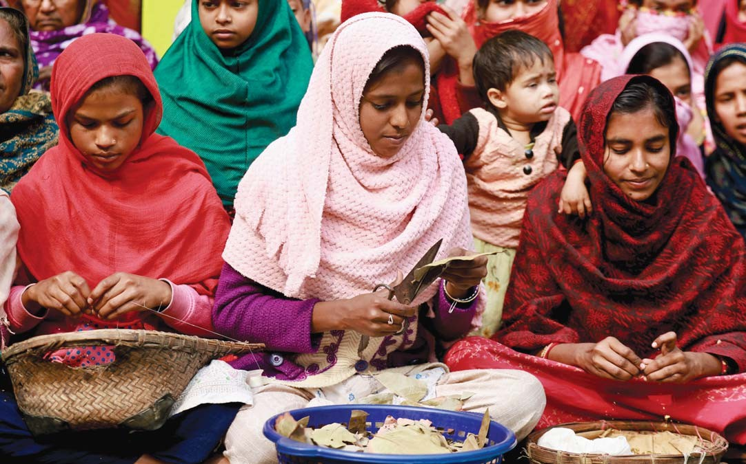

WEALTH

Wealth and wealth creation are the goals of any business. Industrial and business policies and regulations will be designed to facilitate the production of goods and services in larger volumes and higher values. While production is import- ant, productivity is equally important. Any impediment, legal or administrative, to larger production or higher value will be removed. We will facilitate access to finances, raw materials, technology, intellectual property, and other resources both from within India and through imports. Business enterprises will have the liberty to sell goods and services within India or through exports. All laws and rules that inhibit free and fair trade will be reviewed and changed.

India’s GDP in 1990-91 was approximately 25 lakh crore in constant prices. In 13 years, first under a Congress govern- ment and later under coalition governments, the GDP doubled and reached a value of 50 lakh crore in 2003-04. In 10 years under the UPA, the economy doubled again and the GDP was at 100 lakh crore in 2013-14. A 100 lakh crore economy was inherited by the BJP/NDA government but it wasted the golden opportunity. If the UPA had continued in office, the economy would have doubled again and stood at 200 lakh crore in 2023-24. Alas, due to the BJP’s mismanagement, the GDP will reach a level of only 173 lakh crore by the end of 2023-24 falling short of a target that was unachievable.

The Congress is committed to rapid growth and generation of wealth. We have set a target of doubling the GDP in the next 10 years.

WELFARE

Welfare of all is the goal of all work and the creation of wealth. Owing to the skewed policies of the BJP/NDA, the people of India are divided in economic terms. There is a small class of very rich, a substantial middle class, a large segment of people above the poverty line but not yet the middle class, and nearly 22 crore people who are poor.
Under a Congress government, the welfare of the poor will be the first charge on all government resources. It will be the Congress’ endeavour to ensure that the 22 crore people below the poverty line are lifted above the line in the next 10 years; that they are able to enjoy the fruits of education, healthcare, housing, drinking water, sanitation, electricity and, above all, opportunities for jobs/work; and are made strong and self-reliant to compete with others who are higher on the economic ladder.

As people move up the economic ladder, their needs are for better infrastructure and better goods and services. Besides, we must get the Indian economy and the Indian work force ‘future-ready’. The challenges of the future include the changes in the global economy, advanced technology such as Artificial Intelligence, robotics and machine learning, and climate change. The future of our energy is Green Energy. We will mobilize the massive capital required for our green energy transition.

The Nav Sankalp Economic Policy will aim to build a fair, just and equal-opportunity economy and bring prosperity to all sections of the people. Congress will herald a new beginning, just as we did in 1991, involving all sections of the people in nation-building. The time has become to re-set and re-prioritize our roadmap for economic development in the context of the twin challenges to our economy, namely, UNEMPLOYMENT and INFLATION.

We have made specific promises in different sections of this Manifesto. By implementing these promises, we hope to achieve the paramount goal of ushering in a fair, just and equitable economy that will make India a rich country, and that will be resilient to adapt to a changing world.

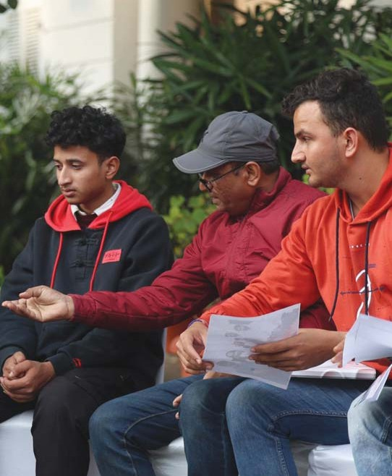
UNEMPLOYMENT – MEETING THE CRY FOR JOBS
The most challenging issue today is widespread
unemployment. The cry everywhere is for jobs. The unemployment rate ranges from 10 per cent (for age 15-29) to 42.3 per cent (for graduates under age 25) to 9.8 per cent (for graduates of age 30-34). No one has any faith in the BJP which deceived the people with the false claim that it will create 2 crore jobs a year. The BJP/NDA government’s response to the grave problem was to abandon labour force surveys, distort data and pretend that the problem does not exist. We acknowledge the problem and we promise to create millions of jobs through concrete initia- tives:

- Fill the nearly 30 lakh vacancies in sanctioned posts at various levels in the central government, teaching and non-teaching posts in central educational institutions, posts of doctors, nurses, paramedics and other support- ing staff in central government medical institutions, and vacancies in the Central Armed Police Forces (CAPF).

- Publish a job calendar for each department, institu- tion and public body with details of vacancies and the timelines to fill the vacancies.

- Abolish the Agnipath programme and direct the Armed Forces (Army, Navy, Air Force and Coast Guard) to resume normal recruitment to achieve the full sanc- tioned strength.

- Appoint a second ASHA worker in all villages with a population exceeding 2,500 persons.

- Double the number of Anganwadi workers and create an additional 14 lakh jobs.

- Create a new employment-linked incentive (ELI) Scheme for corporates to win tax credits for additional hiring against regular, quality jobs.

- Launch a strategic mining programme to explore and mine rare earths and critical minerals with the object of increasing the share of mining to 5 per cent of GDP and creating 1.5 crore jobs for unskilled and skilled workers in the mineral-rich states.
The programme will be implemented consistent with stringent environmental and labour safety standards.

- We will launch an urban employment programme guaranteeing work for the urban poor in reconstruction and renewal of urban infrastructure.

- Provide jobs for low-education, low-skilled youth by launching a Water Bodies Restoration Programme and a Wasteland Regeneration Programme that will be implemented through village panchayats and munici- palities.

- Establish an autonomous non-profit society involving the state governments, universities and business organisations to establish at least one Skills Training Institute in each district to impart skills through short- and long-term courses to youth in the age group of 18-29 years. Incentivise corporates to use CSR funds for skill training in recognised skill training institutes.

- Incentivise panchayats to establish and maintain solar grids that will generate power for common purposes and create jobs at the panchayats level.

- Amend the laws to make workplaces safer for women workers and with facilities for care of small children. Facilitate travel to such workplaces.

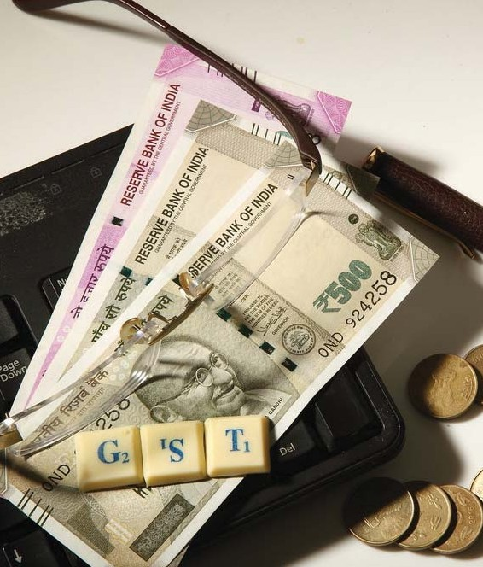

TAXATION AND TAX REFORMS
Taxation forms the core of governance. The last ten years of the BJP/NDA government is a case of “taxation gone berserk”. The share of taxes paid by the common person and the poor through regressive indirect taxes has increased significantly and the share of taxes paid by corporates has decreased – the exact opposite of what a people-friendly and progressive taxation policy should be. Despite the tall claims of increasing the tax base through demonetistion and GST, India’s overall tax to GDP has not increased in the last decade, leaving very little room for increased expendi- ture. Congress will undertake a complete overhaul of India’s taxation system to make it people-friendly and efficient, and to incentivise private savings and investment.

- Congress will enact a Direct Taxes Code that will usher in an era of transparency, equity, clarity and impartial tax administration of direct taxes.

- Congress will maintain stable personal income tax rates throughout its term. This will ensure that the salaried class is not subjected to rising tax rates and have clarity to plan their finances over the medi-
um-to-long period.

- We will eliminate “Angel tax” and all other exploitative tax schemes that inhibit investment in new micro, small companies and innovative start-ups.

- Congress will lessen the burden of tax on MSMEs owned by individuals and partnership firms.

- We will end the duplicitous “cess” raj of the Modi government to deny states their rightful share of tax revenues by introducing a law to limit Union cess and surcharges to 5 per cent of gross tax revenues.

- Congress will replace the GST laws enacted by the BJP/NDA government with GST 2.0. The new GST regime will be based on the universally accepted principle that GST shall be a single, moderate rate (with
- GST will not be levied on agricultural inputs.

- The GST Council will be re-designed. It will be the final authority on policy and on all matters relating to GST.

- The administration of GST laws will be divided horizontally between the central government and the state governments. Small GST-payers below a thresh- old will come under the purview of the state govern- ments.

- A portion of GST revenues will be allocated to pnchayats and municipalities.

- Shopkeepers and small retail businesses that face intense competition from online businesses will be given significant tax relief.

- The Income Tax Appellate Tribunal (ITAT), the Goods and Services Tax Appellate Tribunal (GSTAT) and the Customs Appellate Tribunal (CESTAT) will be autonomous judicial bodies without interference by the government.

a few exceptions) that will not burden the poor.

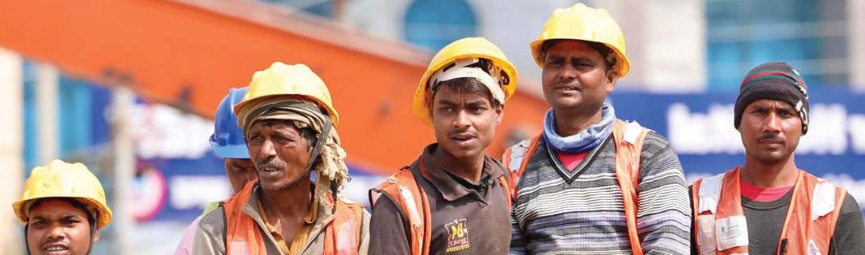
INDUSTRY
In order to become a developed economy and create good quality jobs for hundreds of thousands of youth, it
is critical that India transitions from a consumer economy to a producer economy. India must become a manufacturing powerhouse that produces goods and services for itself and the world. To this end, beyond economic and business factors, the most vital ingredient is social harmony that will attract investments and a skilled labour force. It is thus no surprise that in the last 25 years, India’s manufacturing share of GDP has been higher during the Congress rule. On the contrary, in the last 10 years (2014-24), the share of manufac- turing has stagnated at 14 per cent.

- Congress resolves to make India a manufacturing hub by raising the share of manufacturing from 14 per cent to 20 per cent of GDP in the next five years.

- The most immediate objective will be to restore a healthy, fearless and a trustworthy climate for business- es. While a Congress government in 1991 abolished industrial licensing and controls, the independent regulatory regime that was put in place has deteriorated into a system of overt and covert controls. We will conduct a comprehensive review of the current rules and regulations and repeal or amend them in order to restore freedom to industry, business and trade.

- Congress will aim for India attaining a position of leadership in multiple industries such as steel, metals, garments and textiles, cement, automobiles, electronic goods, pharmaceuticals, engineering goods, petroleum products, chemicals, and mining rare earths and critical minerals.

- According to the RBI, nearly 60 per cent of the large central government projects have been stalled or delayed and costs have risen by nearly 5 lakh crores. Congress will address the problem in a mission-mode and find ways and means to revive the stalled projects with the help of the private sector.
- Congress will reform the production-linked incen- tives (PLI) scheme to target specific sectors that can create thousands of jobs by making India one of the top 5 producers in the world in that sector.

- We will introduce a new employment-linked incentive (ELI) Scheme for corporates to win tax credits for additional hiring against regular, quality jobs.

- We will give the highest priority to intellectual property rights and to the registration, acquisition, protection and use of IPR in small, medium and large businesses.

- Congress will create a level playing field for all businesses. We are opposed to monopolies and oligopolies. We will strengthen the Competition Com- mission of India in order to ensure that India will be an open and competitive economy.

- Congress will simplify the corporate taxation struc- ture and end tax terrorism. We will restrain the investi- gating agencies from misusing their powers to reward or punish corporates and ensure that they act within the strict limits of the law.

- We will encourage and support the use of Artificial Intelligence, robotics, etc. which will create new and frontline jobs. At the same time, we will ensure that there are more job opportunities in sectors that use conventional technology.

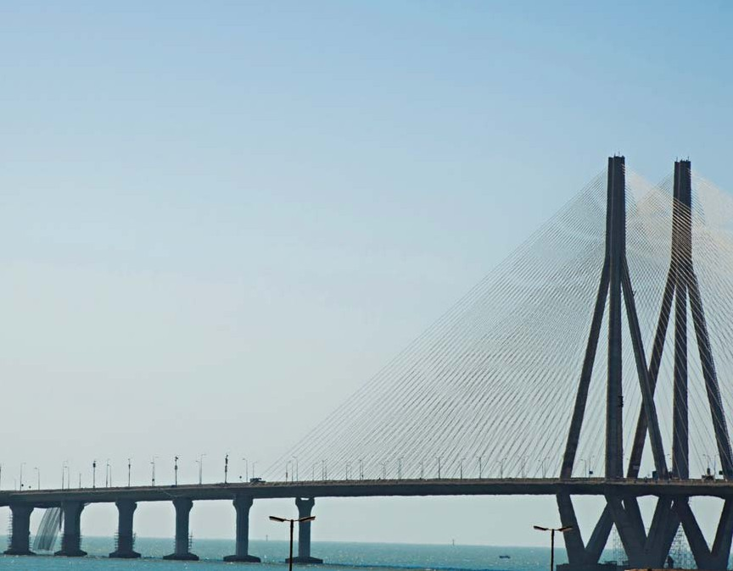

INFRASTRUCTURE
The hardware of an economy are roads, railways, ports, airports and electricity. Capital expenditure and modern technology have to be mobilized to create infrastructure of world class quality. A variety of models of building infrastructure must be adopted according to the needs of the economy.

- Congress will mobilize public and private capital, increase the pace of construction, and augment infra- structure. The focus will be on design, quality, speed of implementation, maintenance and accountability.

- Private capital must be attracted to create public assets and infrastructure. The BJP/NDA government has inverted this model and is using public money to create assets that eventually find their way into private hands. Congress will stop this loot of public money.

- We will modernise the outdated railway infrastructure but in doing so we will ensure that trains and stations serve the needs of the common people and commuters. The railway services and facilities available to the poor and middle classes will be continued.

- KAVACH, an anti-collision device, was developed during the term of the UPA. KAVACH will be installed in all train engines and routes to improve passenger safety on Indian railways.

- Transport facilities and connectivity between rural areas and the nearby town/city will be augmented so that people may live in rural areas and work in urban areas.

- Congress will implement a comprehensive plan for multi-modal urban public transport.
- Road tolls are perceived by the road-users as excessive and exploitative. The policy on Road Tolls will be reviewed and formulae will be applied to deter- mine the toll amount and the period of levy for each stretch of the road.

- A regulatory regime for ports and airports will be established to promote efficiency and competition among ports/airports.

- We will promote green energy. We will implement renewable energy schemes that will make the panchayats or municipality self-sufficient in electricity as far as possible. We will promote solar-powered engines for tapping groundwater for agriculture.

- We will ensure that modern scientific methods for exploration and extraction of natural resources are followed to protect and preserve the local environment and communities. Representatives from the concerned panchayat or municipality will be consulted before undertaking such projects.

FEDERALISM

Centre-State Relations
Federalism is the foundational principle of ‘India is a Union of States’. India’s fabric of federalism stitched together by mutual trust between the Union and States has been systematically destroyed by the BJP/NDA government. Congress affirms its belief that India cannot be administered by the central government alone. In most matters concerning the daily lives of the people, it is the state government that is close to the people and, in some matters, it is the local government (panchayats or municipality) that is closer to the people.

- We will review the distribution of legislative fields in the Seventh Schedule of the Constitution and build a consensus on transferring some fields from List III (Concurrent List) to List II (State List).

- India is one and many at the same time. Its unity gets strengthened when its diversities are accommodated and celebrated. This has always been Congress’ stance and will remain so. Article 1 of the Constitution begins with the words “India, that is Bharat, shall be a Union of States.” This is the guiding principle of federalism in our country.

- Congress will end the duplicitous “cess” raj of the BJP/NDA government to deny states their rightful share of tax revenues. We will introduce a law to limit Union cess and surcharges to 5 per cent of gross tax revenues.

- We will instruct the Finance Commission to take into account factors such as demographic performance and tax efforts in determining the shares of states in the devolution of central tax revenues. We will work with state governments to evolve a formula to devolve funds, including a share of GST revenues, directly to pancha- yats and municipalities.

- Taking into account rapid urbanisation, we will amend the laws to grant more executive, financial and adminis- trative powers to the directly-elected Mayor/Chairperson for effective governance in urban local bodies. The administration will be accountable to the Mayor/Chair- person and the Council.

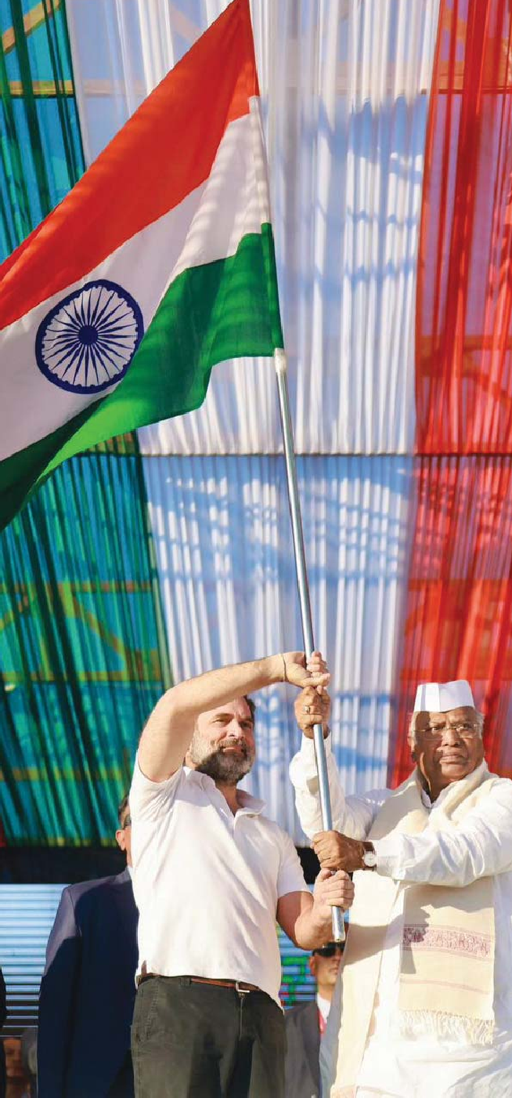

- Congress, as the author of the 73rd and 74th Consti- tution Amendments, will prevail upon the states to implement those provisions in letter and spirit and devolve funds, functions and functionaries upon the panchayat and municipality.

- Congress will enhance the role and authority of Gram Sabhas in matters concerning village panchayats. We will enhance the authority of the Gram Sabha in the administration of the following Acts:
(a.) The Panchayats (Extension to Scheduled Areas) Act, 1996.
(b.) The Forest Rights Act, 2006.
(c.) The Land Acquisition Act, 2013.

- Congress will enhance financial assistance to the Autonomous District Councils in the North Eastern states.

- We will immediately restore full statehood to Jammu and Kashmir. We will amend the Sixth Schedule of the Constitution to include the tribal areas of Ladakh.
- We will give Special Category status to Andhra Pradesh as promised on 20 February 2014.

- We will amend the Government of National Capital Territory of Delhi Act, 1991 and declare that the Lieutenant Governor shall act on the aid and advice of the Council of Ministers of NCT, Delhi on all matters, including Services, except on matters concerning the three reserved subjects.

- We will grant full statehood to Puducherry.

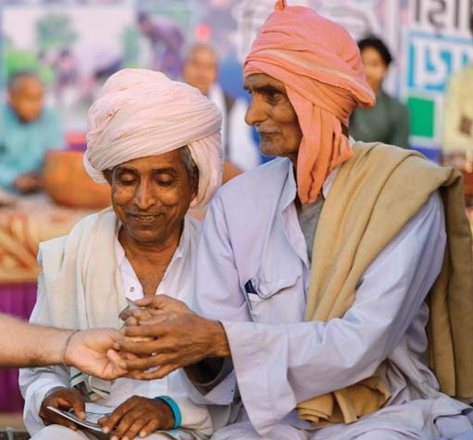
RURAL AND URBAN DEVELOPMENT
The two realities that India faces are (1) that nearly 60 per
cent of the people live in rural areas and (2) urbanisation is taking place rapidly. Hence, we have to pay equal attention to rural development and urban development, and provide adequate infrastructure in our villages and towns/cities.
Some issues like livelihoods, housing, water, electricity, habitat, pollution, climate change, transport and disaster management are common to both rural and urban areas.

- For rural areas, Congress will pass the Right to Homestead Act, extend the Pradhan Mantri Gram Sadak Yojana to all villages and habitations, and increase the funds to and quicken the pace of implementation of the National Drinking Water Mission.

- We will increase the wage under MGNREGA to 400 per day. MGNREGA funds and workers may also be deployed to build public assets such as classrooms, libraries and primary health centres.

- We will launch an urban employment programme guaranteeing work for the urban poor in reconstruction and renewal of urban infrastructure.
- To regulate the mindless expansion of existing cities, Congress will support the construction of a twin city near an existing city but separated by a clear green and no-construction zone between the old and new cities.

- To improve urban governance, the Mayor/Chairper- son will be directly elected for a fixed term of 5 years along with a Council. Executive, financial and adminis- trative powers will be conferred upon the Mayor/Chair- person. The administration will be accountable to the Mayor/Chairperson and the Council.

- Transport facilities and connectivity between rural areas and the nearby town/city will be augmented so that people may live in rural areas and work in urban areas.

- Congress will implement a comprehensive plan for multi-modal urban public transport.

- Travel/transport will be made safer for women and children, especially in towns and cities.

- The menace of stray dogs has acquired alarming proportions. Solutions will be found that will protect humans (especially children) and that are consistent with a humanitarian approach to animals.
- We will prevail upon the states to implement the 73rd and 74th Amendment to the Constitution in letter and spirit and ensure that funds, functions and functionaries are devolved upon the panchayats and municipalities.

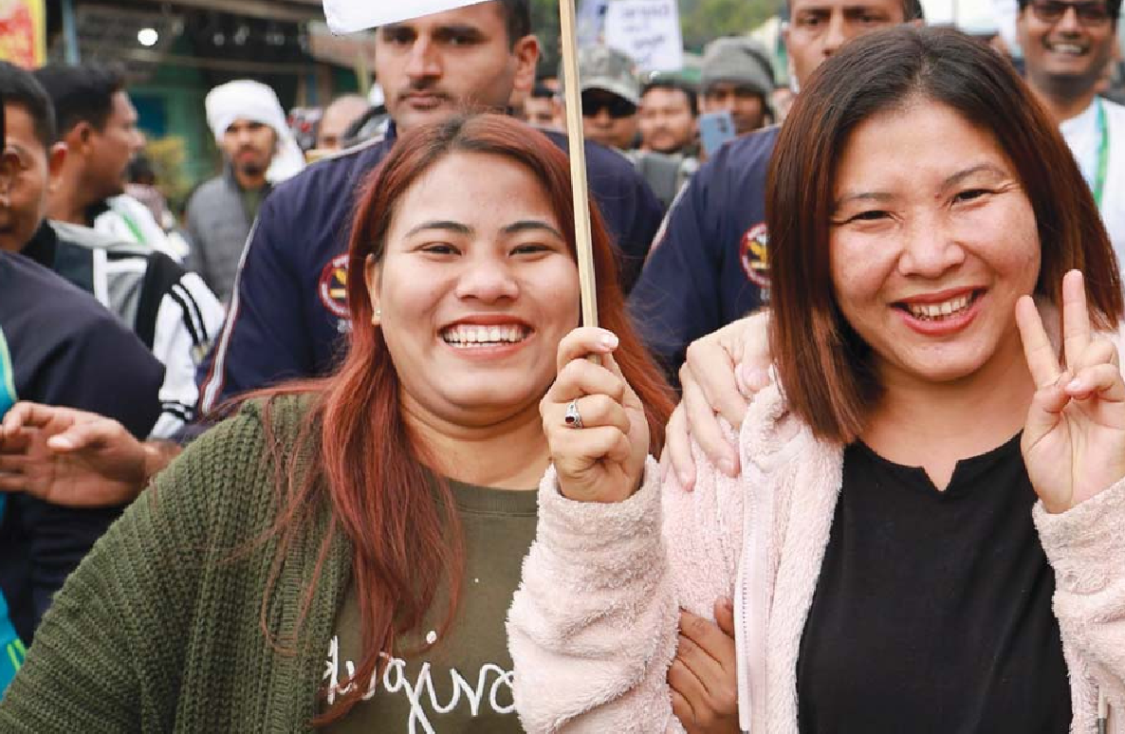

NORTH EASTERN STATES
The North Eastern states within the Union of India represent the pluralism and diversity of India. We are proud that we are a diverse country that is home to many races, religions and languages.

- We will assess the infrastructure deficit in the North Eastern states and provide more funds for building infrastructure.

- We will support Border Trade and make every effort to increase the volume and value of such trade.

- Congress will revive the Autonomous District Coun- cils (ADCs) in the North Eastern states and make them an effective instrument of local government. We will ensure that more funds are channelised through the ADCs for developmental works.

- We will ensure that tea garden workers receive fair wages and other benefits in accordance with the applicable laws and agreements.
- The situation in Manipur has gone from bad to worse due to the callous neglect of the BJP/NDA government. Congress will remove the present state government forthwith and heal the wounds between the communities. We will appoint a Reconciliation Commission to bring about a political and administra- tive settlement that will be satisfactory to all the people of the state.

- We will ensure appropriate compensation and redress for the victims and survivors of the conflict in Manipur.

- A final solution and agreement will be entered into with the Naga groups on the basis of the preliminary agreement that had been agreed in 2013-14.

NATIONAL SECURITY

Defence
The Chinese intrusions in Ladakh and the Galwan clash in 2020 represented the biggest setbacks to Indian national security in decades. On 19 June 2020, PM Narendra Modi gave a clean chit to China that considerably weakened our negotiating position. Despite 21 rounds of military-level talks, Chinese troops continue to occupy Indian territory and deny Indian forces access to 26 out of 65 patrolling points, equivalent to an area of 2,000 square km in eastern Ladakh. A Chinese buildup in Doklam threatens the Siliguri Corridor that connects northeast India with the rest of the country.

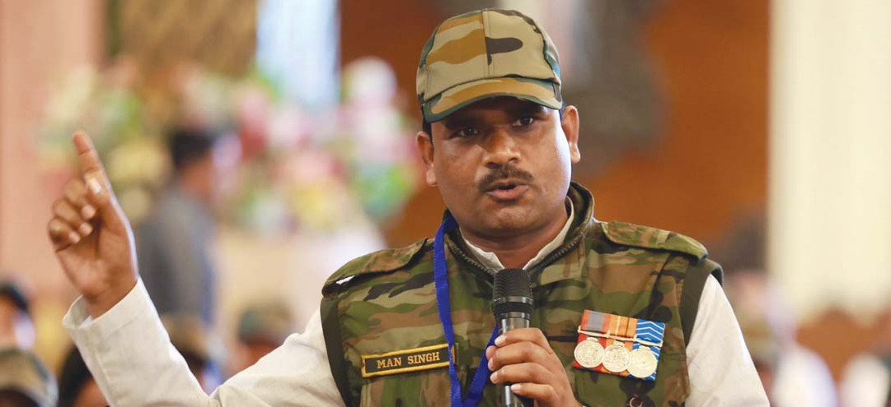

- The absence of a formal National Security Strategy has led to ad hoc and personalised policymaking. After detailed deliberations, Congress will issue a comprehensive National Security Strategy.

- The Raksha Mantri’s Operational Directive determines the Armed Forces’ war planning. The UPA government issued the last directive in 2009. Congress will bring a new Operational Directive to deal with our current
two-front challenge.

- The Chief of Defence Staff (CDS) is a sensitive and crucial post for military reform, preparedness and joint operations. Congress will institutionalise the process of appointing the CDS to ensure transparency and military consensus.

- We will reverse the decline in defence expenditure as a proportion of total expenditure and will ensure that sufficient funds are allocated and spent to meet the requirements of the Armed Forces.
- Congress will scrap the Agnipath Scheme and return to the normal recruitment processes followed by the Army, Navy and Air Force that will guarantee economic and social security for our soldiers.

- Congress will systematically expand the opportuni- ties for women to serve in combatant and non-combat- ant roles in the Armed Forces.

- The National Security Council (NSC) and the office of National Security Adviser (NSA) will be brought under the oversight of a select committee of Parlia- ment.

- The concept of national security in the 21st century has expanded beyond defence of the territory to include hybrid warfare, data security, cyber security, financial security, communication security and security of trade routes. Congress will evolve suitable policies to address each of these subjects.

- Congress will establish a National Economic Security Board under the NSC with the following objec- tives:
(a.) to monitor possible risks to global supply chain disruptions and suggest counter actions;
(b.) to suggest measures to reduce over-dependence on large import sources;
(c.) to recommend future courses of action toward inward and outward investments that will strengthen India's footprint in the world;
(d.) to monitor global financial flows and identify potential threats to India, along with actions required to mitigate them in advance; and
(e.) to work on digital/cybersecurity issues that may threaten India's digital financial infrastructure.
- We will rapidly expand domestic capacity to manufacture defence and security hardware and equipment.

- One Rank One Pension (OROP) will be implemented in accordance with the order of the UPA government dated 26 February 2014. Anomalies that have arisen in the implementation of OROP by the BJP/NDA govern- ment will be rectified. We will restore the disability pension and make it tax-free.

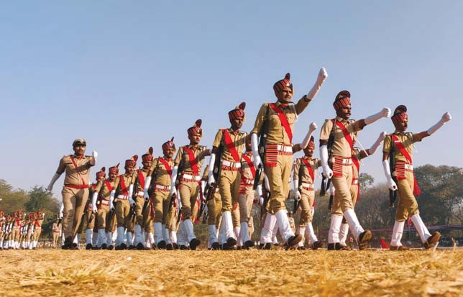
INTERNAL SECURITY
In the aftermath of the Mumbai terror attacks in 2008, Congress revamped the internal security system and implemented a number of radical measures. Distressingly, gaps have emerged in the system. Besides, the increase in hate speeches, hate crimes and communal strife has compounded the situation.

- Congress will put down with a firm hand hate speech- es, hate crimes and communal conflicts. According to NCRB data, crimes against women, SC, ST and minori- ties have increased. We will identify the perpetrators of such crimes as well as their sponsors and punish them in accordance with law.

- Congress is firmly opposed to extra-judicial illegal measures like mob lynching, police encounter killings and bulldozer justice. We will stop them immediately and punish the perpetrators in accordance with law.

- The unfinished agenda of the 2008 reforms are:
•NATGRID and
•National Counter-Terrorism Centre.
Congress will take up the two subjects, complete the work, and operationalise them within one year.
- The State police is the first responder to threats to internal security. Congress will work with State govern- ments to build, train and equip the State police forces to maintain law and order and to punish offenders without fear or favour.

- Trafficking and selling of drugs will be put down with a firm hand. Increasingly, ports are used to smuggle drugs. The regulatory and penal provisions will be strengthened, and drug smugglers and traffickers, and their accomplices, will be dealt with sternly in accor- dance with law.

- The strength of the Central Armed Police Forces (CAPF) will be augmented and modernized. Our goal is that 33 per cent of these forces will be made up of women. The Service Rules will be revised and updated. The forces will be deployed having regard to the needs of training, rest and recuperation.

- We will fill the vacancies in the CAPF and achieve the full sanctioned strength.

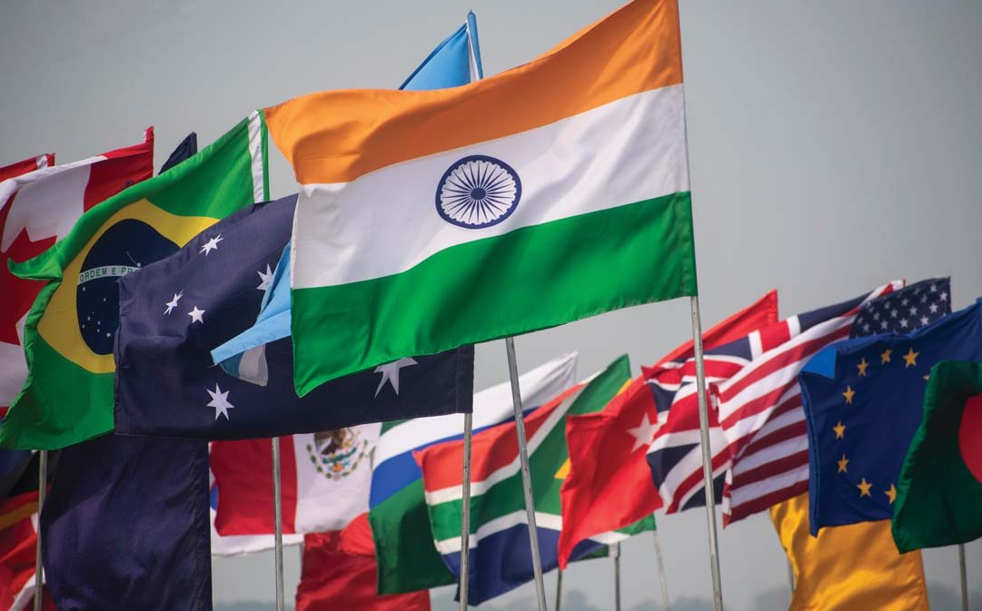
FOREIGN POLICY

- Congress affirms and will uphold continuity in India’s foreign policy. Our approach was profoundly shaped by the freedom movement and developed through the wisdom of visionary leaders like Jawaharlal Nehru.

- There was a consensus on foreign policy since Independence. Unfortunately, in many areas, foreign policy under the BJP/NDA government has witnessed marked departures from this consensus, notably on the ongoing Gaza conflict. Congress pledges to restore India’s global reputation as a voice of peace and moder- ation in world affairs.

- Congress re-affirms its firm belief in the continued relevance of the established policy of peaceful co-exis- tence, strategic autonomy in thought and action, and increased bilateral engagement in its relations with the countries of the world.

- We will work to strengthen India’s role in multilateral institutions, co-ordinate positions with other countries of the Global South on vital issues, and continue to work for reform and empowerment of international organisa- tions to deal with the major challenges that transcend borders.
- Enhanced foreign trade will be an important element of our foreign policy and we will make every effort to conclude long-pending trade negotiations with other countries in the interests of Indian producers and consumers.

- Congress is implacably opposed to terrorism anywhere in the world. We will work with other coun- tries to eliminate terrorist groups, terrorist acts and cross-border terrorism.

- Congress will work to repair India’s international image that has been damaged by the present govern- ment’s intolerance of dissent and suppression of human rights.

- Congress recognises that national security is not enhanced by chest-thumping or exaggerated claims but by quiet attention to our borders and resolute defence preparedness. We will work to restore the status quo ante on our borders with China and to ensure that areas where both armies patrolled in the past are again accessible to our soldiers. We will take the necessary steps to adjust our policy towards China until this is achieved.

- Congress will pay greater attention to our immediate neighbours. We will re-establish the primacy of our special relationships with Nepal and Bhutan and strengthen them to our mutual benefit. We will enhance economic and cultural relations between India and Bangladesh that are the two most populous countries in South Asia. We will work with Sri Lanka to restore the political and commercial relations between the two countries and help Sri Lanka resolve its political issues especially with the Tamils. We will repair relations with the Maldives and work with Myanmar to protect the political and human rights of the people of Myanmar.

- Engagement with Pakistan depends fundamentally on its willingness and ability to end cross-border terrorism.
- Congress will significantly increase the size of the Indian Foreign Service, open more missions abroad, leverage our economic strengths, and acquire a position of leadership through the country’s values and mutually beneficial economic relationships.

- We will revive the position of a Minister of State handling overseas Indians within the External Affairs Ministry to provide this important constituency with a one-stop window to address their concerns.

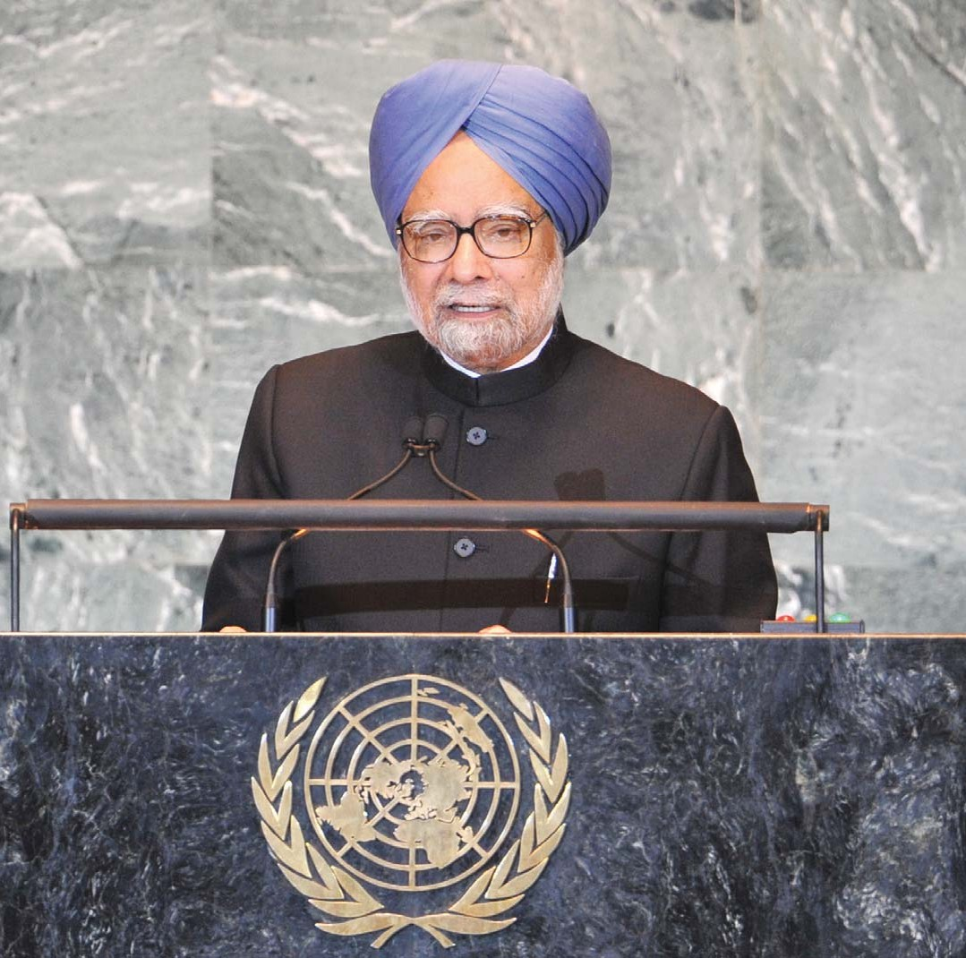

ENVIRONMENT

Environment, Climate Change and Disaster Management
Congress re-affirms its profound commitment to rapid, inclusive and sustainable development, and to protect its ecosystems, local communities, flora and fauna. We recall that it was Prime Minister Indira Gandhi who first put in place the laws, regulations and institutions for that purpose. The National Action Plan on Climate Change was prepared under the leadership of Prime Minister Manmohan Singh. Despite the BJP’s misinformed criticism of the Action Plan, the BJP/NDA government subsequently acknowledged its relevance and validity. However, there have been several departures from the previous policies and important components such as environment protection, forest conservation, biodiversity preservation, coastal zone regulation, wetlands protection and protection of tribal rights have been weakened.

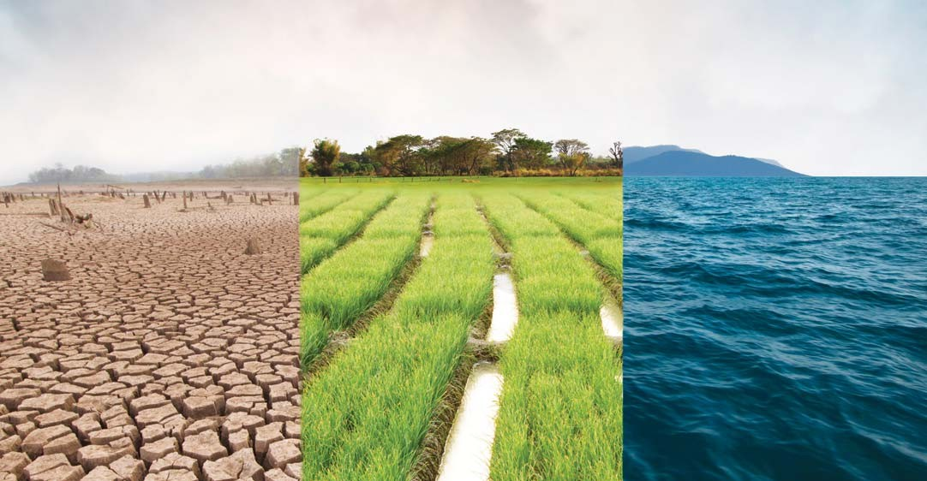

Air pollution and water pollution continue to extract a heavy toll on public health. Livelihoods are being destroyed in tribal and ecologically sensitive areas.

Congress will address the issues of environment and climate change with the seriousness they deserve.

- We will constitute an independent Environment Protection and Climate Change Authority to establish, monitor and enforce environmental standards and to enforce the National and State Climate Change plans.

- We will launch a Green New Deal Investment Programme focused on renewable energy, sustainable infrastructure and the creation of green jobs.
- We will strengthen the National Clean Air Programme in order to urgently tackle the problem of air pollution.

- Congress will work with state governments to stop the discharge of effluents into the rivers and water bodies of India.

- Congress will appoint a high-level committee to study the issue of landslides in the hill districts, evolve measures to prevent landslides and ensure citizens’ safety.

- Congress will protect the coastal zones of the country. The coastal zones will be preserved without affecting the livelihood of fishing communities.

- India experienced the biggest loss of forest cover after Brazil between 2015 and 2020. We will work with state governments to increase the forest cover, redefine ‘forest’ and ‘forest cover’ in accordance with modern scientific standards, and involve local communities in afforestation.

- Congress will provide clean cooking fuel at affordable prices to all households of the country. We will ensure that the use of LPG cylinders is increased from the current paltry average number of 3.7 per year among Ujjwala beneficiaries.
- In order to facilitate the funding required for Green Transition and to achieve the goal of net zero by 2070, we will set up the Green Transition Fund of India together with state governments and the private sector.

- We will not limit disaster management to humans and will expand it to include other vulnerable lives such as wild animals, domestic animals, pets and livestock.

- We will increase the allocation to the National Adaptation Fund and review the guidelines for use of the Fund.

- We will transition from the 2008 National Action Plan on Climate Change to a National Climate Resil- ience Development Mission to ensure that all sectors of development provide protocols for action and measurable targets.

- Conflicts between humans and wildlife have increased. We will intervene and find solutions that are specific to the areas of conflict.

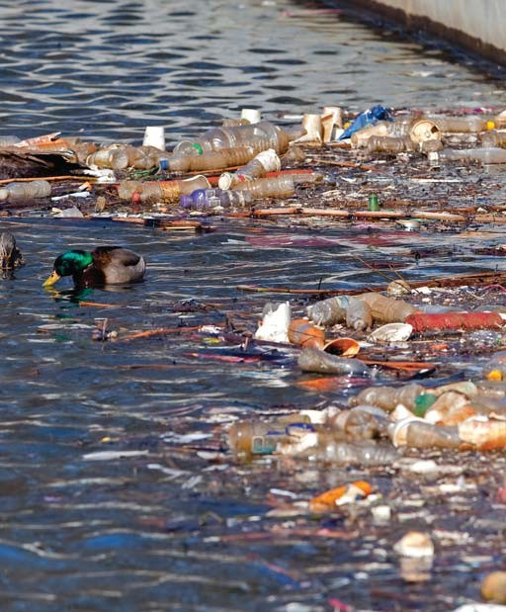

WATER MANAGEMENT AND SANITATION
India has 18 per cent of the world’s population but only 4 per cent of water resources. Climate change and an erratic monsoon have added to the water stress felt by farmers, industries, consumers and others.

- Congress will expand the remit of the Ministry of Jal Shakti and bring all water-related activities and depart- ments under one authority.
- We will implement a nationwide plan to provide potable water in all cities, towns and village panchayats.

- Water harvesting will be made mandatory. Desalina- tion plants will be installed in all coastal areas. The use of recycled water will be promoted for non-drinking and industrial purposes.

- Congress will pay special attention to access to water and democratic sharing of water. We will address these issues by focusing on storage in dams and water bodies, replenishing groundwater and creating a large participatory programme of water management involving the state governments, civil society organisations, farmers, panchayats and gram sabhas, and municipalities.

- Our rivers are polluted because of the discharge of effluents into the rivers. Discharge of any kind of effluent into rivers will be prohibited by law. Pancha- yats and municipalities will be required by law to devise and implement schemes for disposal of effluents and waste.
- Congress will end the evil of manual scavenging. Every manual scavenger will be rehabilitated, re-skilled, provided a job and assured a life of dignity and safety. The Prohibition of Manual Scavenging Act, 2013, will be strictly implemented and any person employing anyone for manual scavenging shall be punished. We will provide compensation of 30 lakh to families of sanitation workers deceased while at work. We will allocate sufficient funds to enable the procurement of machines that will clean sewers and septic tanks, and remove human waste. Free insurance will be provided to all sanitation workers.

- In collaboration with state governments, a compre- hensive programme of underground drainage and safe disposal of sewage will be implemented in all towns and municipalities in 10 years.

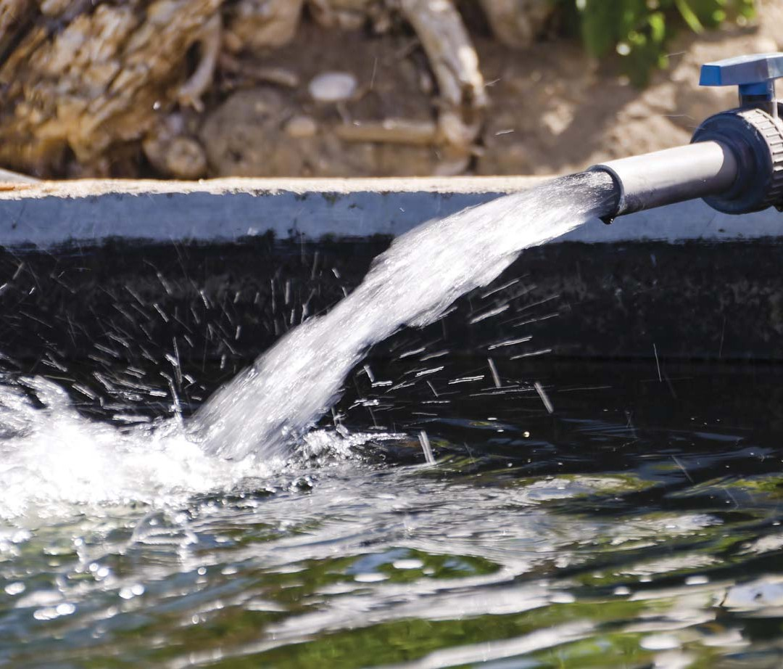

AN APPEAL

The ten years of the BJP/NDA government have been marked by exaggeration and publicity rather than substance and performance. The economy has registered less-than-satisfactory growth. Widespread unemployment, high inflation and falling consumption have debilitated even this modest growth.

While the poor and the middle classes have been hit below the belt, the atmosphere in the country has become hate-filled and divisive. Constitutional values have been pushed to the background and majoritarianism has taken over.

Inequalities have widened. Every section of the people lives in fear.

What India and the Indian people need at this time is a decisive break from the path of the last ten years. The people yearn to walk on the road of all-round development, equality, equity, freedom and justice. Congress has the capability to provide the leadership to the people to walk on this new road.

The lessons of history are there before you. Congress delivered Independence. Congress laid the foundations of democracy. Congress steered the country’s economic development through the 1950s and 1960s. Congress govern- ments fought the wars of 1965 and 1971 and protected the sovereignty and integrity of India. Congress brought about a paradigm change in 1991 and ushered in an era of impressive growth. In the last ten years, the Congress has been the bulwark against illiberalism and authoritarianism. Congress has stood with the people in their fight against injustice and oppressive laws.

Bearing in mind the lessons of history, the Congress appeals to you to repose your faith once again in the Indian National Congress.

We promise you greater freedom, faster growth, more equitable development and justice for all. We appeal to you to vote for the ‘Hand’ symbol and for the candidates of the Indian National Congress

It is time to remind ourselves of Tagore’s immortal words in Gitanjali:

Where the mind is without fear and the head is held high Where knowledge is free
Where the world has not been broken up into fragments By narrow domestic walls
Where words come out from the depth of truth
Where tireless striving stretches its arms towards perfection Where the clear stream of reason has not lost its way
Into the dreary desert sand of dead habit Where the mind is led forward by thee Into ever-widening thought and action
Into that heaven of freedom, my Father, let my country awake.

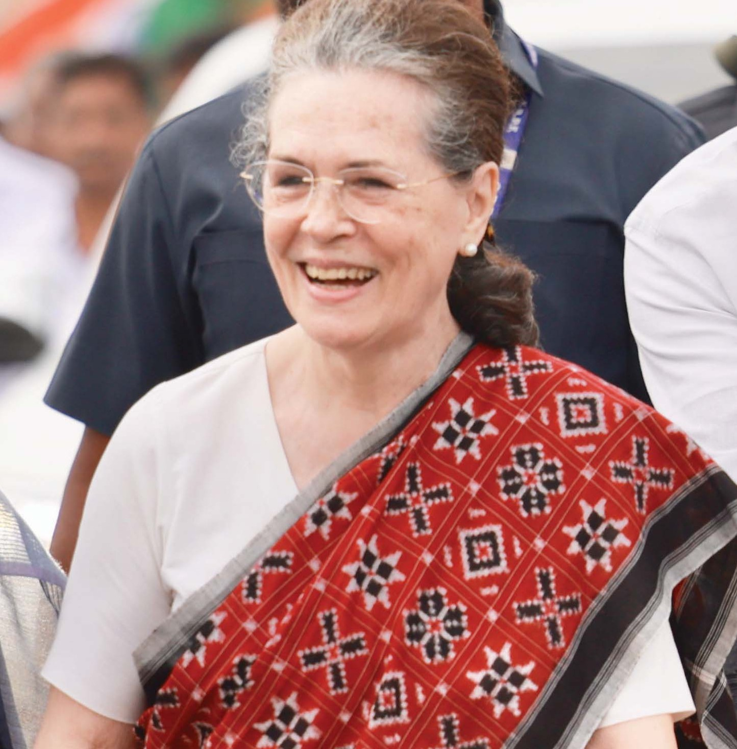

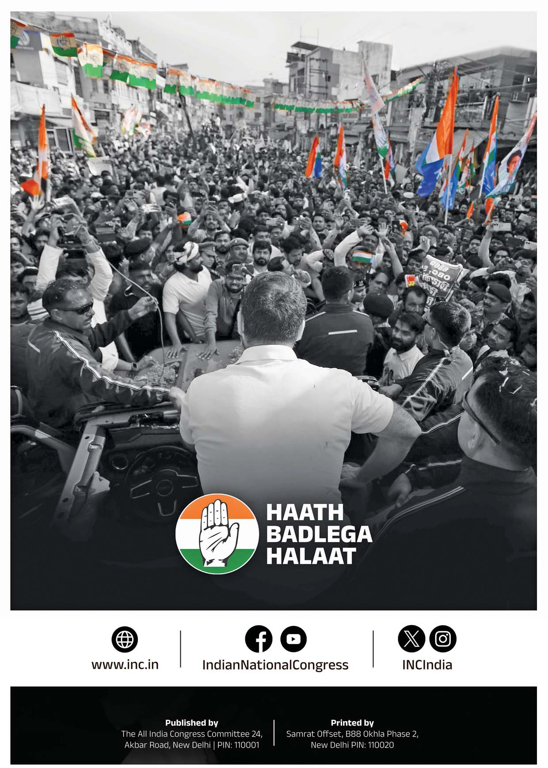
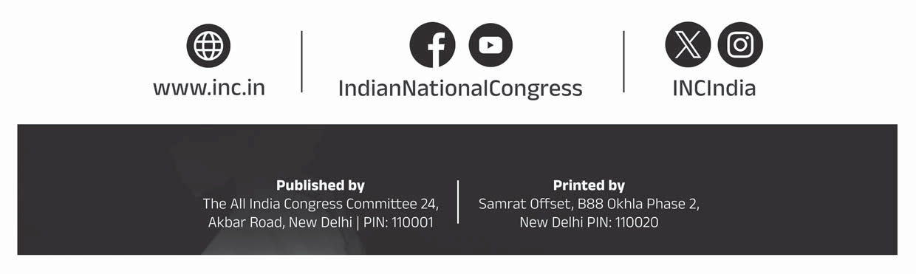

Qty : 3000
1

